**Updated Report summary**

**29.5.20**

**Github Daily update Status report**

The following is the links of github account of the students

<https://github.com/alvas-education-foundation/ankit/tree/master/daily_progress>

<https://github.com/alvas-education-foundation/Disha_Shetty>

<https://github.com/sathvikshetty22>

<https://github.com/ShilpaUddanna/Daily-updates-of-online-activities>

<https://github.com/Shreetal>

<https://github.com/Shrinivasakunder>

<https://github.com/ShwethaKhadri/Shwetha-M-S>

https://github.com/lsindhungowda/Daily-report

https://github.com/Sneha35/OnlineCourse-And-Coding

<https://github.com/ashu102>

<https://github.com/msspoorthi/DailyUpdate-aiet->

<https://github.com/spoorthybalaji>

<https://github.com/alvas-education-foundation/Srilatha-K-Kamath-Daily-Report>

<https://github.com/mssuhas/certification-and-online-coding>

<https://github.com/SPSSURYA/Online-Coding-And-Certification-Course>

<https://github.com/sushmithaganiga/Report>

<https://github.com/Sushmithabp/Daily-report>

<https://github.com/SyedHudaif>

**DAILY ONLINE ACTIVITIES SUMMARY**

**Shetty Disha Ravindra**

|  |  |  |  |  |  |  |  |  |
| --- | --- | --- | --- | --- | --- | --- | --- | --- |
| **Date:** | **28-05-2020** | | | | | **Name:** | **Shetty Disha Ravindra** | |
| **Sem & Sec** | **VI B sec** | | | | | **USN:** | **4a17cs087** | |
| **Online Test Summary** | | | | | | | | |
| **Subject** | | **Operating System** | | | | | | |
| **Max. Marks** | | **30** | | **Score** | | | **24** | |
| **Certification Course Summary** | | | | | | | | |
| **Course** | **Full Stack web Development** | | | | | | | |
| **Certificate Provider** | | | **Udemy** | | **Duration** | | | **19.5hrs** |
| **Coding Challenges** | | | | | | | | |
| **Problem Statement:1]** Given an array arr[] of the positive integers of size N, the task is to find the largest element on the left side of each index which is smaller than the element present at that index. Note: If no such element is found then print -1.  2] Python program to find digital root of a number | | | | | | | | |
| **Status:executed** | | | | | | | | |
| **Uploaded the report in Github** | | | | | **Yes** | | | |
| **If yes Repository name** | | | | | <https://github.com/alvas-education-foundation/Disha_Shetty> | | | |
| **Uploaded the report in slack** | | | | | **Yes** | | | |

Online Test Details: (Attach the snapshot and briefly write the report for the same)

Certification Course Details: (Attach the snapshot and briefly write the report for the same)

Coding Challenges Details: (Attach the snapshot and briefly write the report for the same)

Online test

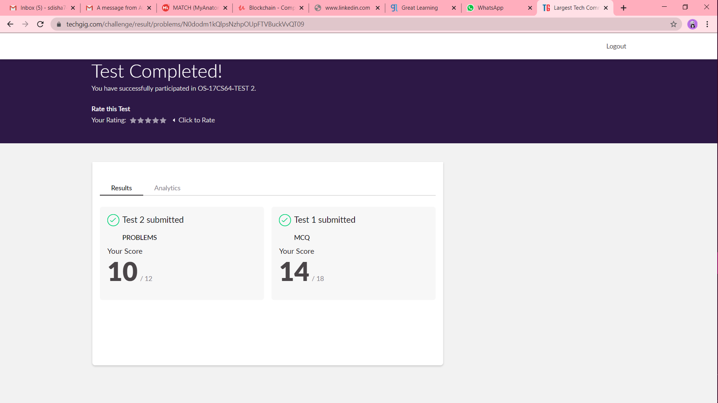

Certification progress

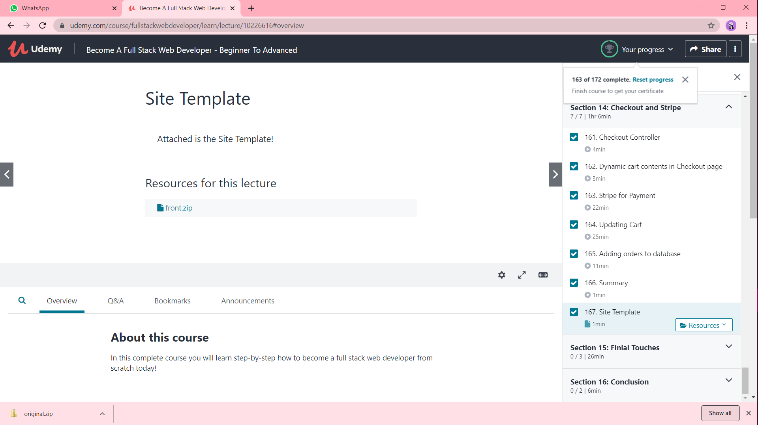

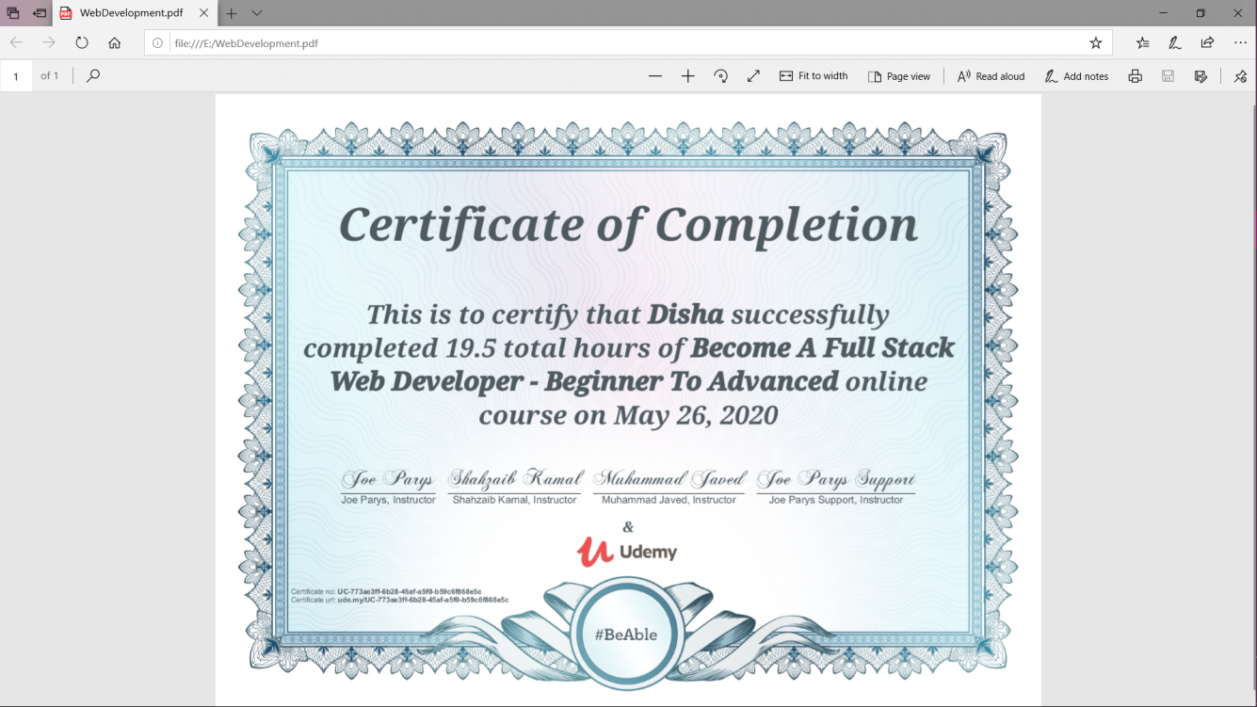

Coding challenge output

1]

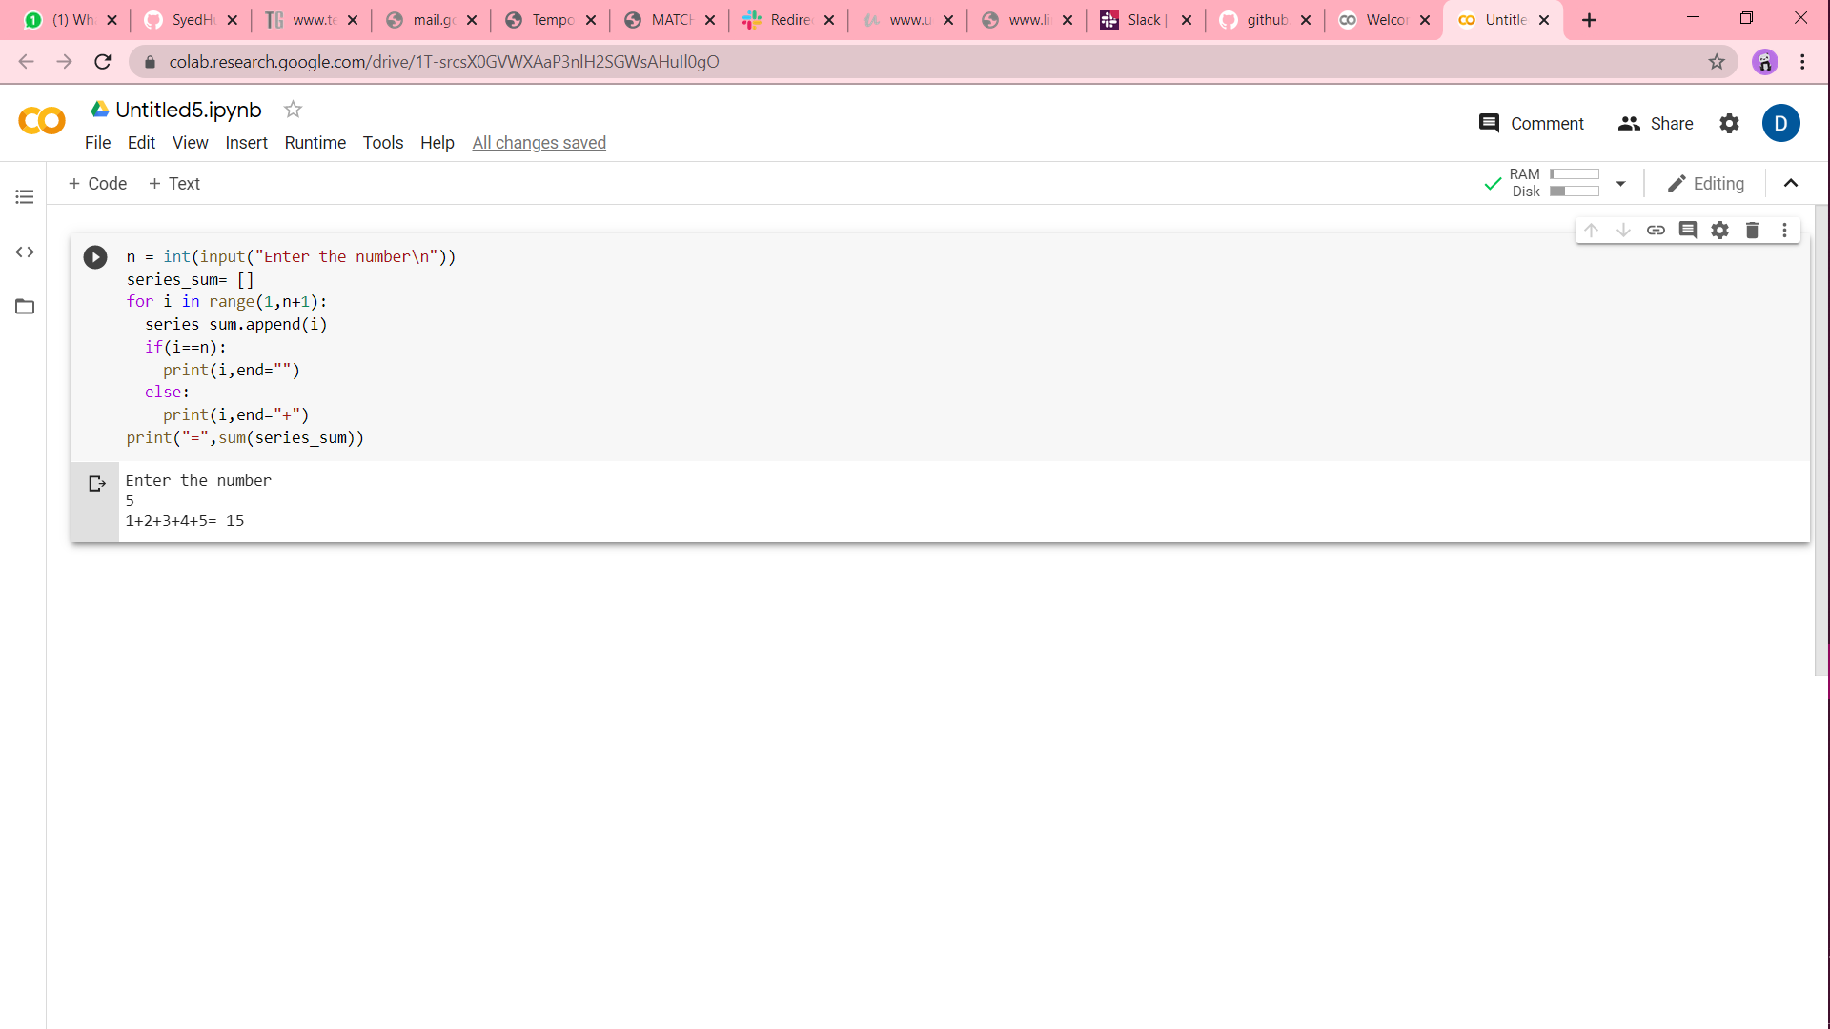

2]

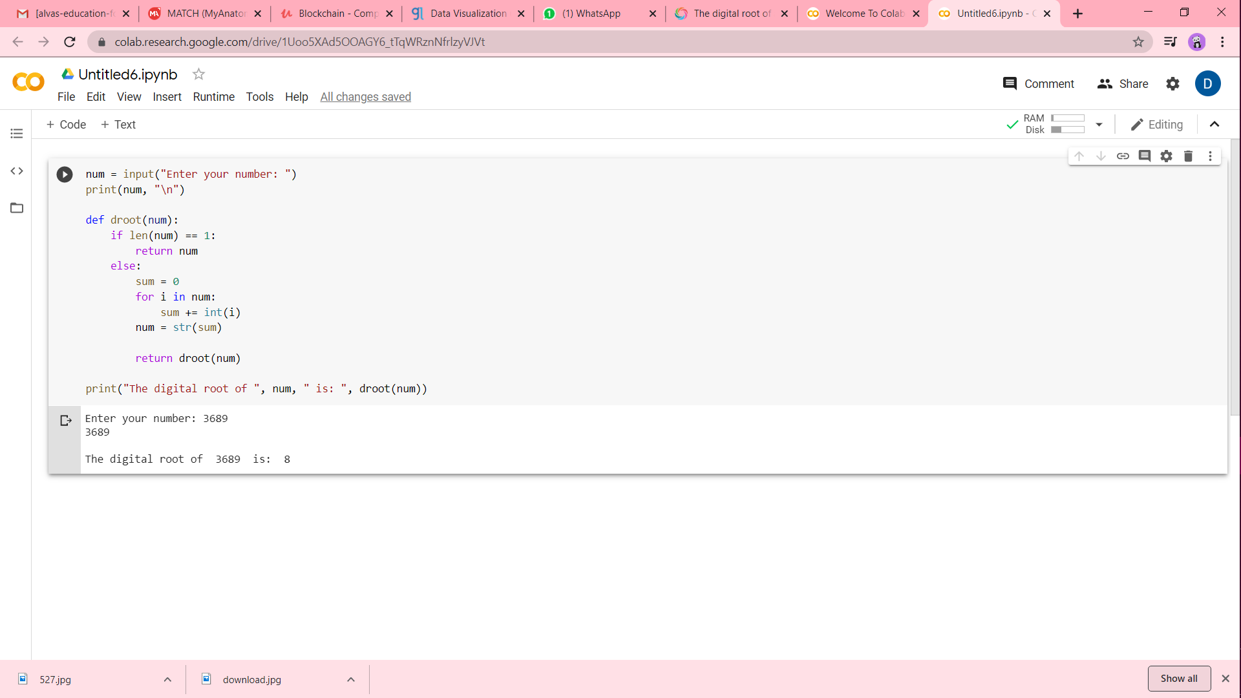

**DAILY ONLINE ACTIVITIES SUMMARY**

**Sathvik R Shetty**

|  |  |  |  |  |  |  |  |  |  |
| --- | --- | --- | --- | --- | --- | --- | --- | --- | --- |
| **Date:** | **28/05/2020** | | | | | | **Name:** | **Sathvik R Shetty** | |
| **Sem & Sec** | **6th /B** | | | | | | **USN:** | **4AL17CS089** | |
| **Online Test Summary** | | | | | | | | | |
| **Subject** | | **OS IA Test - 2** | | | | | | | |
| **Max. Marks** | | **30** | | **Score** | | | | **N.A(Technical Problem)** | |
| **Certification Course Summary** | | | | | | | | | |
| **Course** | **Web Development with Python and JavaScript** | | | | | | | | |
| **Certificate Provider** | | | **Harvard University** | | **Duration** | | | | **12weeks** |
| **Coding Challenges** | | | | | | | | | |
| **Problem Statement:**   1. Python Program to print the greatest integer in the list without using sort(). 2. Python Program to find digital root of a number. | | | | | | | | | |
| **Status: Completed** | | | | | | | | | |
| **Uploaded the report in GitHub** | | | | | | **Yes** | | | |
| **If yes Repository name** | | | | | | <https://github.com/sathvikshetty22/Online-Coding> | | | |
| **Uploaded the report in slack** | | | | | | **Yes** | | | |

**Online Certification Details**

**Lesson**

* Testing, CI/CD

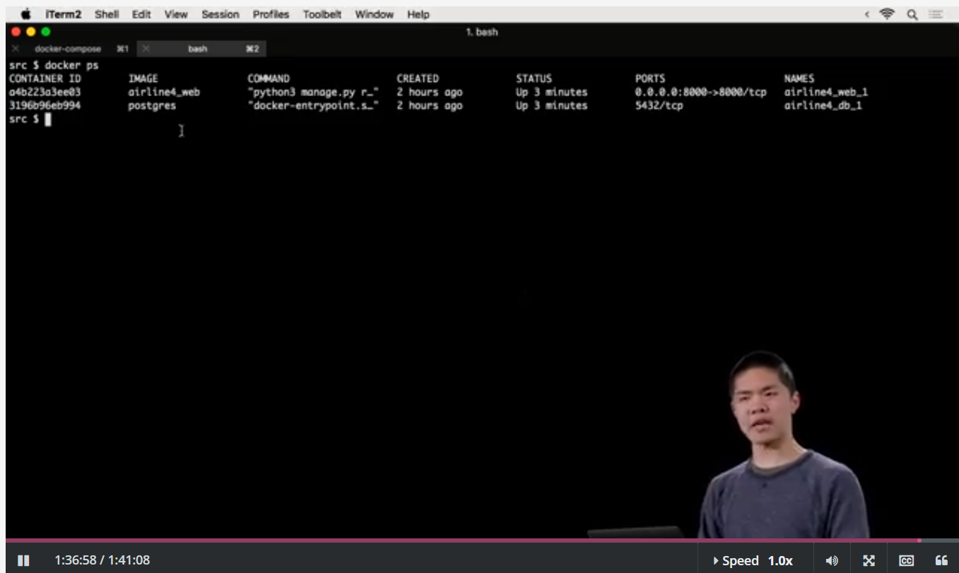

**Coding Challenge Details**

1. Python Program to print the greatest integer in the list without using sort().

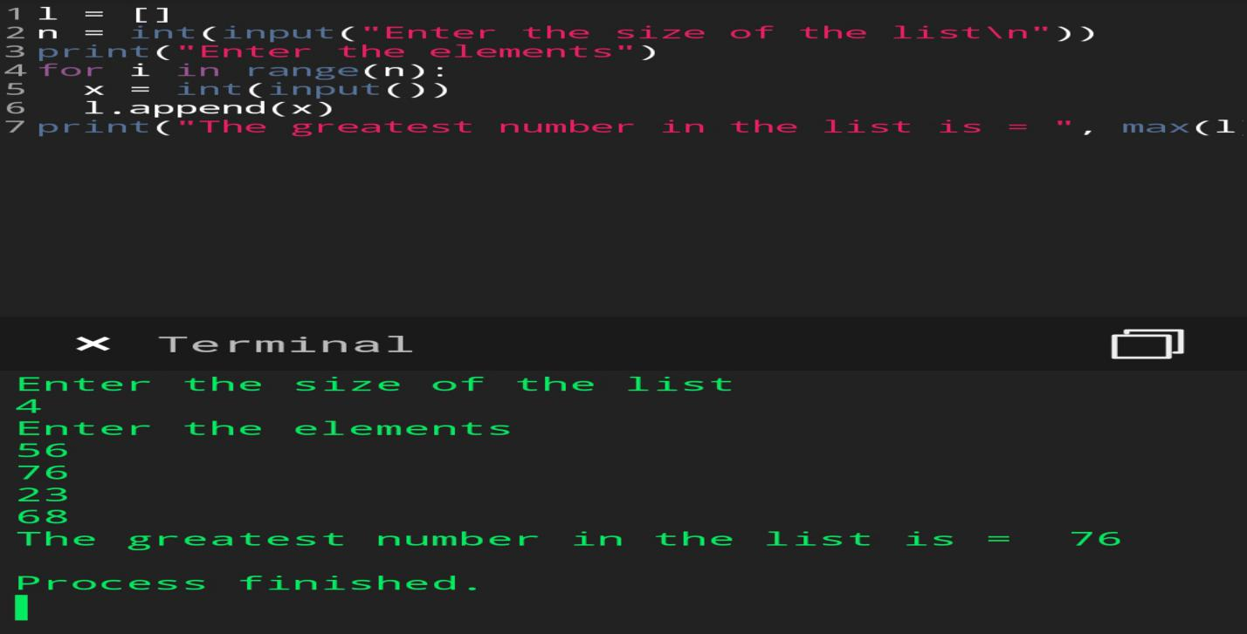

1. Python Program to find digital root of a number.

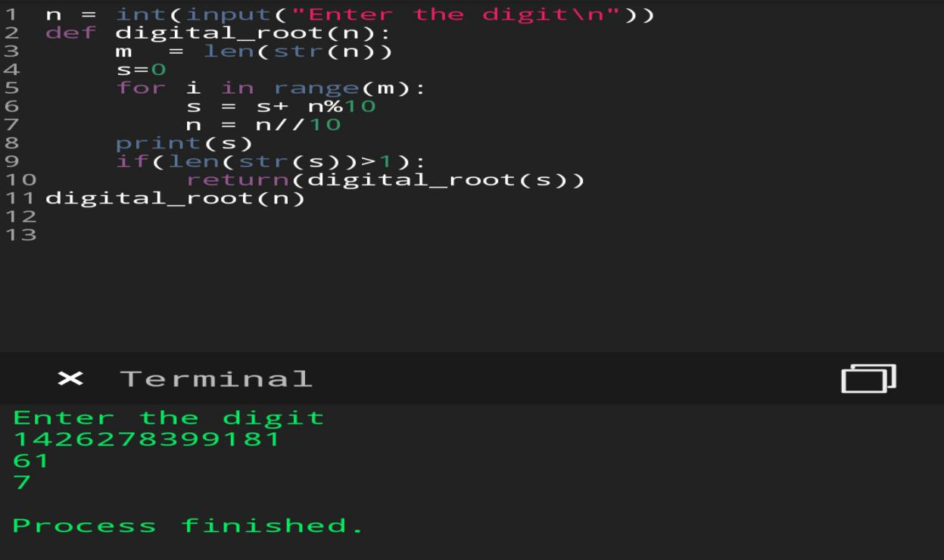

**DAILY ONLINE ACTIVITIES SUMMARY**

**Shilpa S.U**

|  |  |  |  |  |  |  |  |  |
| --- | --- | --- | --- | --- | --- | --- | --- | --- |
| **Date:** | **28 MAY2020** | | | | | **Name:** | **Shilpa S.U** | |
| **Sem & Sec** | **VI & B** | | | | | **USN:** | **4AL17CS090** | |
| **Online Test Summary** | | | | | | | | |
| **Subject** | | **Operating System** | | | | | | |
| **Max. Marks** | | **30** | | **Score** | | | **24** | |
| **Certification Course Summary** | | | | | | | | |
| **Course** | **Machine Learning with Python** | | | | | | | |
| **Certificate Provider** | | | **CognitiveClass** | | **Duration** | | | **15 hours** |
| **Coding Challenges** | | | | | | | | |
| **Problem Statement:** **1)Write a Java program to get to know the balanced bracket if its balanced it will print true or else print false.**  **2)Write a Python program to get the digit root of a given number until it becomes single digit.** | | | | | | | | |
| **Status: Done** | | | | | | | | |
| **Uploaded the report in Github** | | | | | **Yes** | | | |
| **If yes Repository name** | | | | | **Daily status** | | | |
| **Uploaded the report in slack** | | | | | **Yes** | | | |

Online Test Details: (Attach the snapshot and briefly write the report for the same)

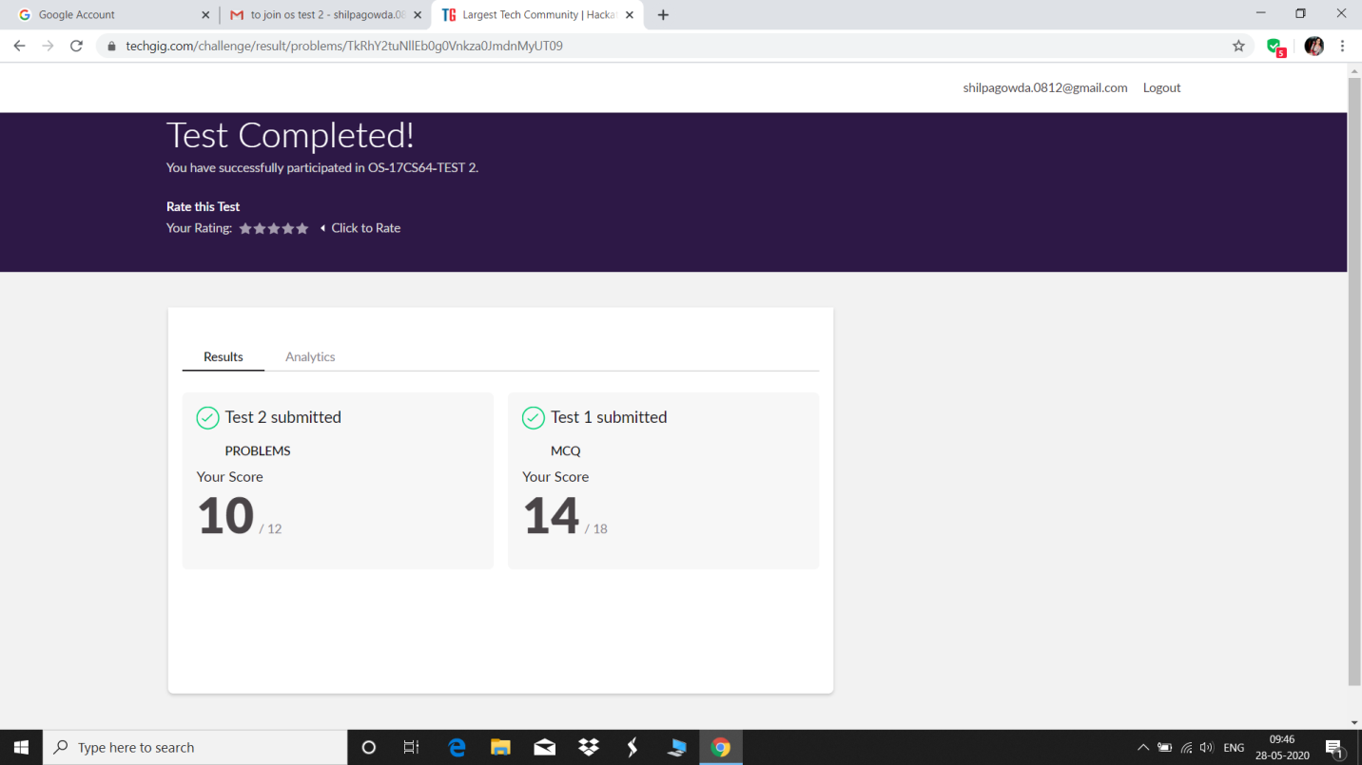

Certification Course Details: (Attach the snapshot and briefly write the report for the same)

1.

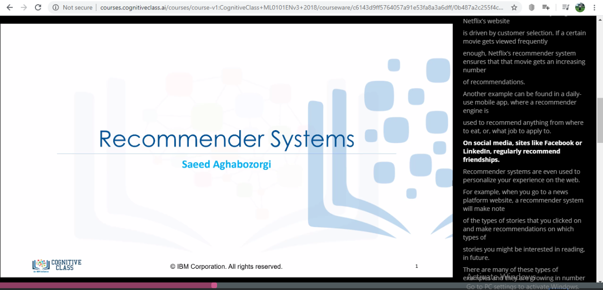

2.

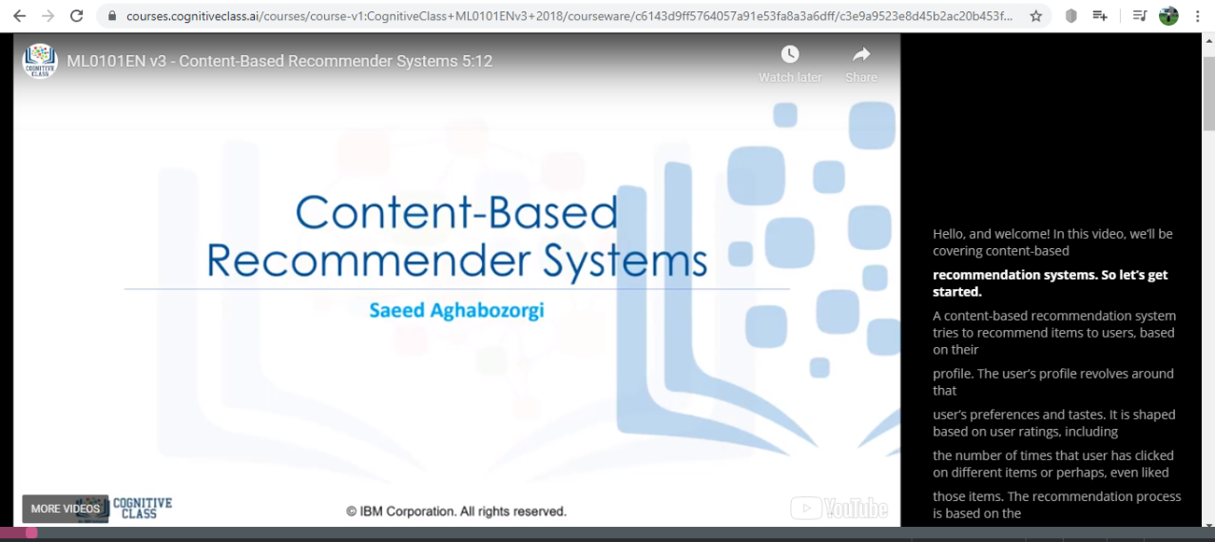

3.

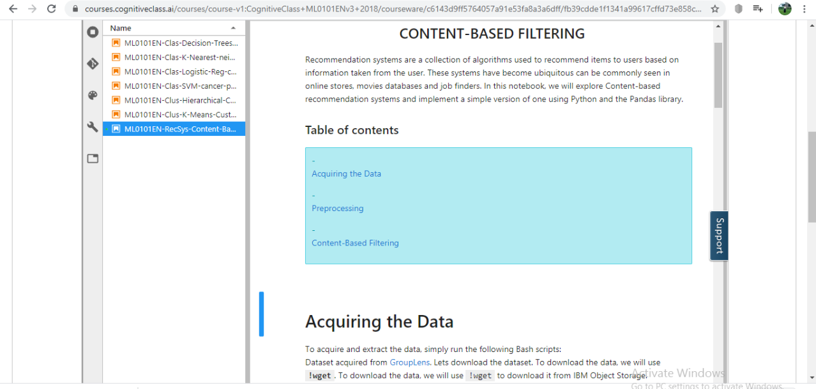

**BRIEF REPORT:**

1. Recommender systems try to capture these patterns  
   and similar behaviors, to help predict what else you might like.  
   * Recommender systems have many applications that I’m sure you’re already familiar  
   with. Indeed, Recommender systems are usually at  
   play on many websites. For example, suggesting books on Amazon and  
   movies on Netflix.
2. In fact, everything on Netflix’s website  
   is driven by customer selection. If a certain movie gets viewed frequently  
   enough, Netflix’s recommender system ensures that that movie gets an increasing number  
   of recommendations**.**
3. Recommendation systems are a collection of algorithms used to recommend items to users based on information taken from the user. These systems have become ubiquitous can be commonly seen in online stores, movies databases and job finders. In this notebook, we will explore Content-based recommendation systems and implement a simple version of one using Python and the Pandas library

Coding Challenges Details: (Attach the snapshot and briefly write the report for the same)

1

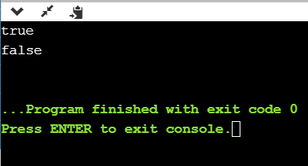

This program checks for equal no of brackets is open and closed if so it prints true or else return false

2.

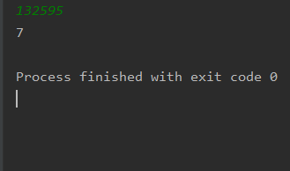

This python program is to get digitroot of the number where we give a random number and until it become complete single digit it goes on calculate

3.

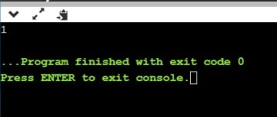

This c program prints last remaining element in array

4.

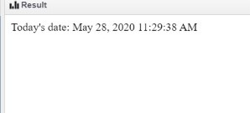

JSP program to print current date and time.

5.

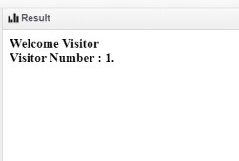

Jsp program to print number of visitor visited the site**.**

**Format for uploading details in Github and Slack in word file format**

**28/5/20**

**Student Name : Shreetal Kalabandi**

**Class and Sec : VI B**

**USN : 4AL17CS091**

|  |  |  |  |  |
| --- | --- | --- | --- | --- |
| **Online Test Details** | | | | |
| **Subject** | **Operating System** | | | |
| **Semester** | **VI - B** | | **Duration** | **50 Minutes** |
| **80%** | | **24/30** | | |

**Encl : snapshot of the test result**

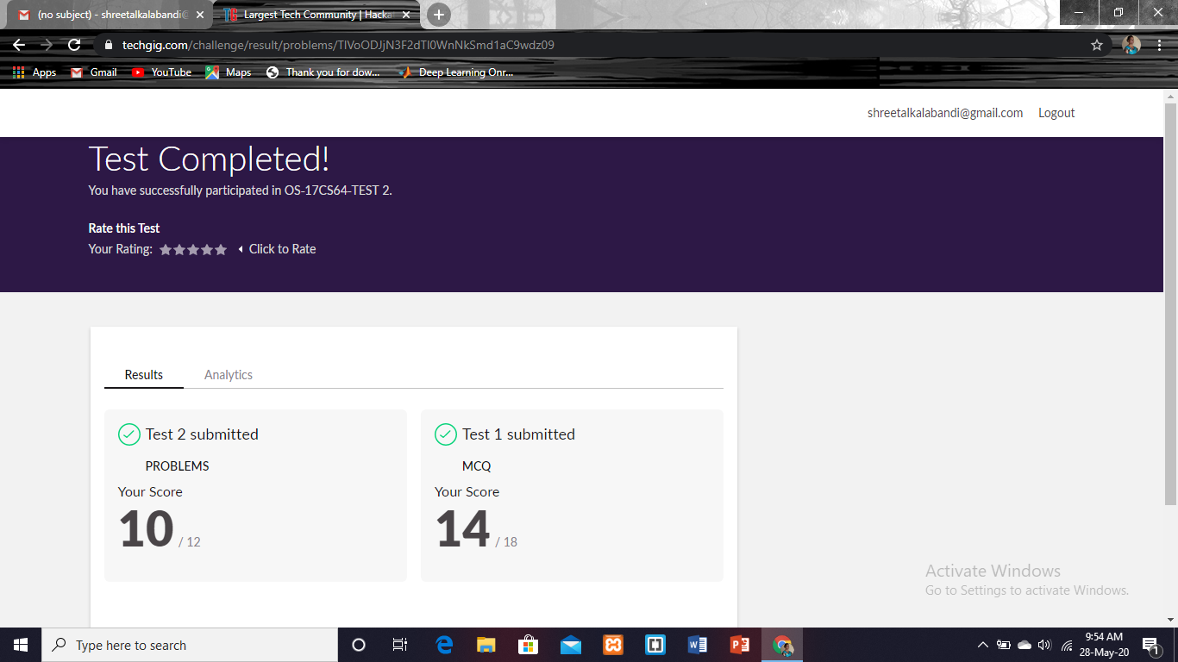

|  |  |  |  |
| --- | --- | --- | --- |
| **Certification Course Details** | | | |
| **Course** | **Python for Data science** | | |
| **Certificate Provider** | **Cognitiveclass.ai** | **Duration** | **6 hours** |

**Encl : snapshots of the daily class acitivities (atleast two snap shots)**

**Progress on 28-05-2020**

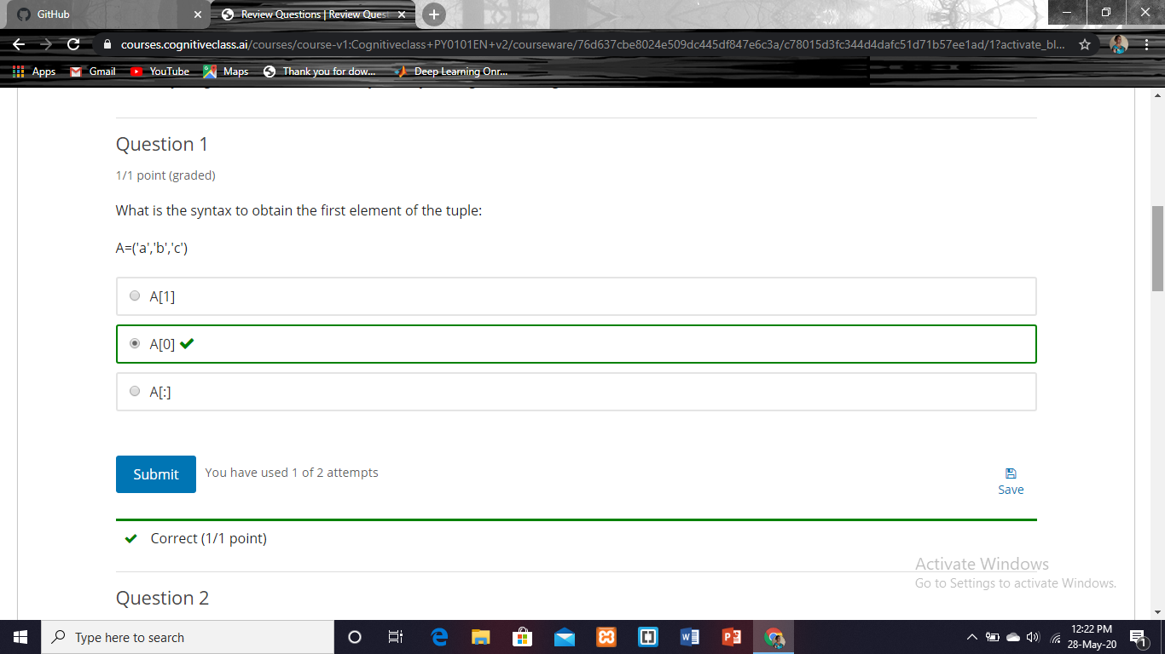

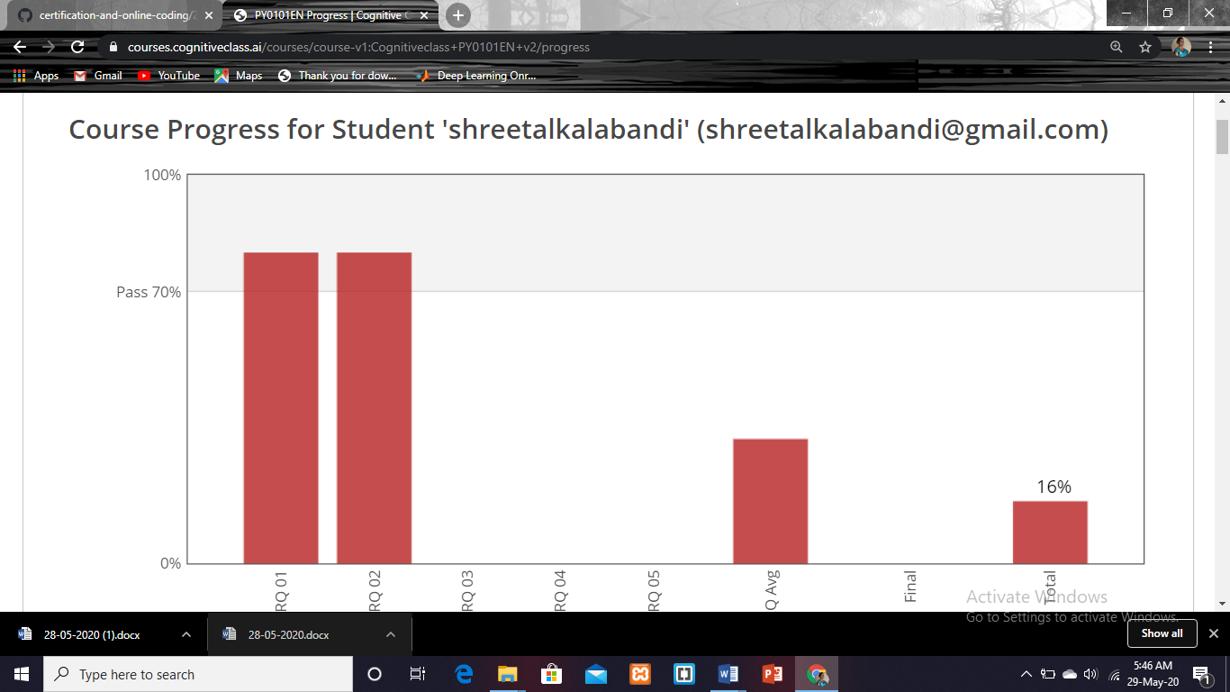

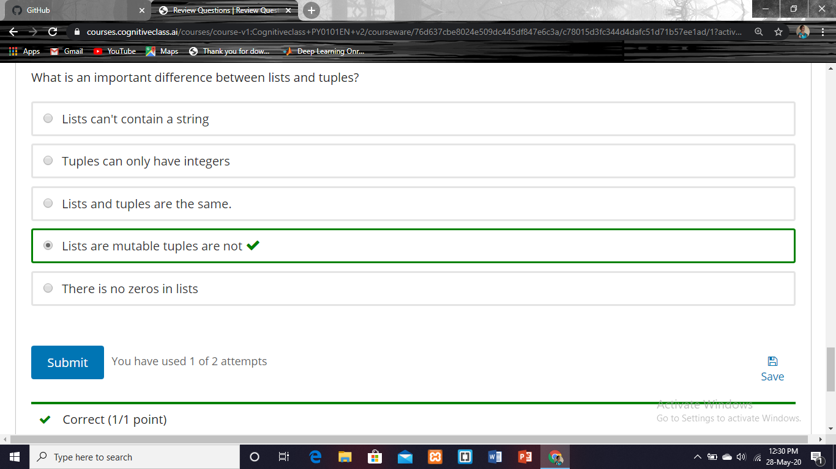

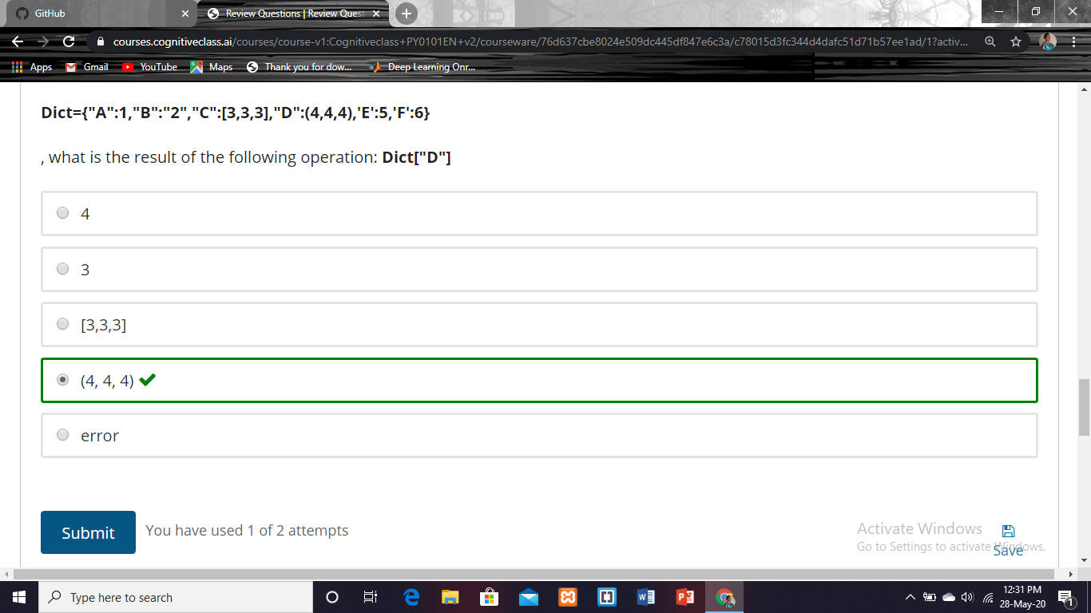

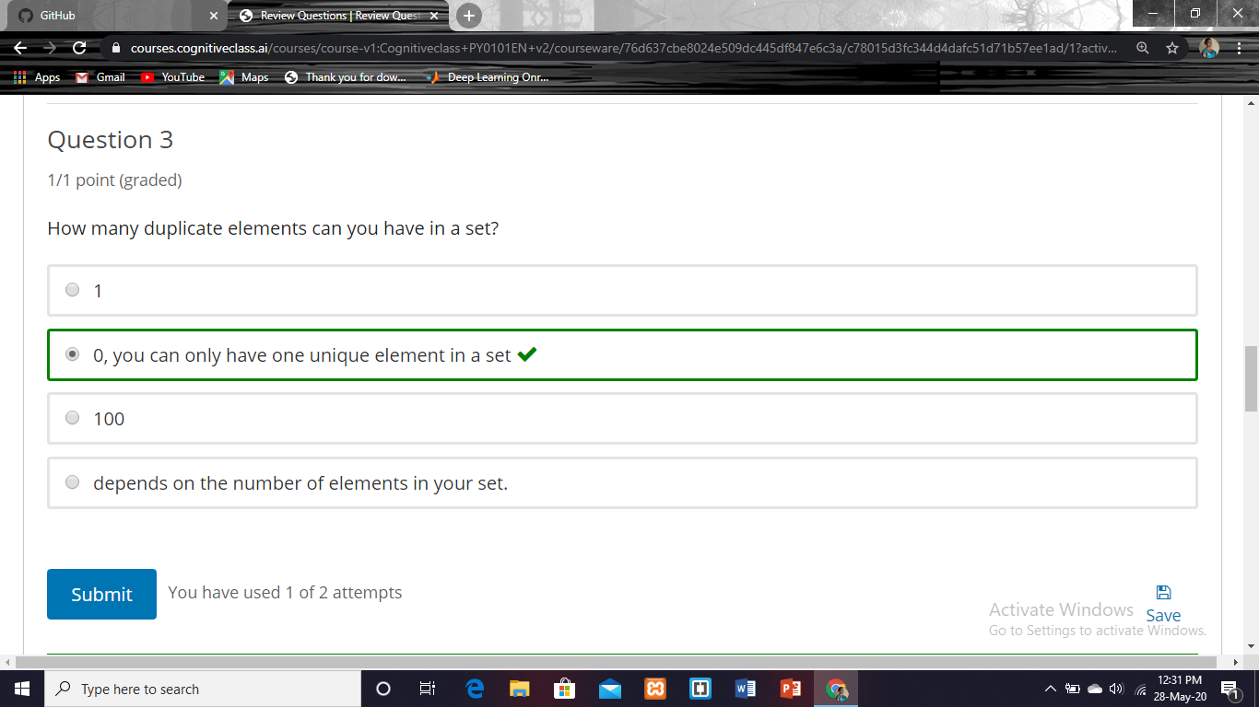

|  |  |
| --- | --- |
| **Coding Challenges** | |
| **Problem Statement:Pro1(python), Pro2(java), Pro3(java), Pro4(jsp), Pro5(jsp)**  **.** | |
| **Status: Completed** | |
| **Uploaded the report both in Github & Slack** | **Yes** |

**Encl : snapshots of your response to challenge.**

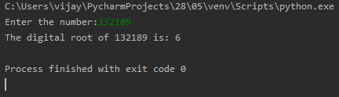

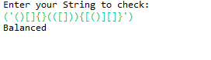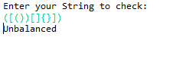

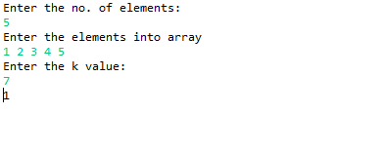

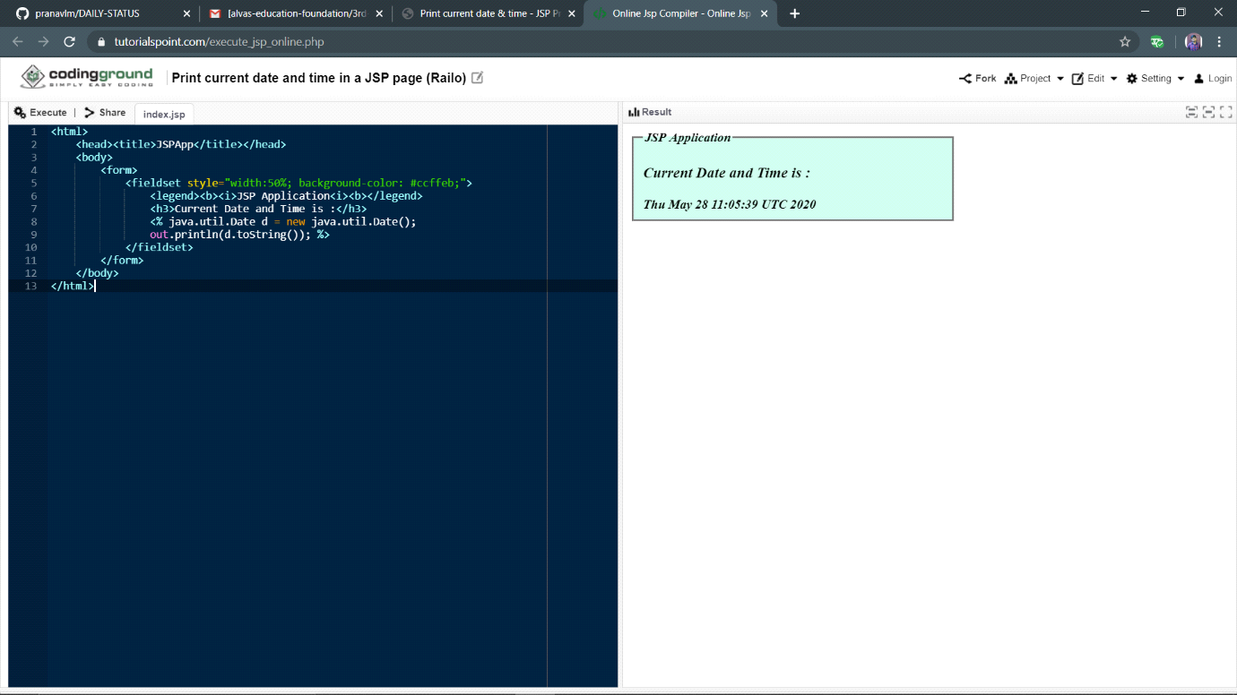

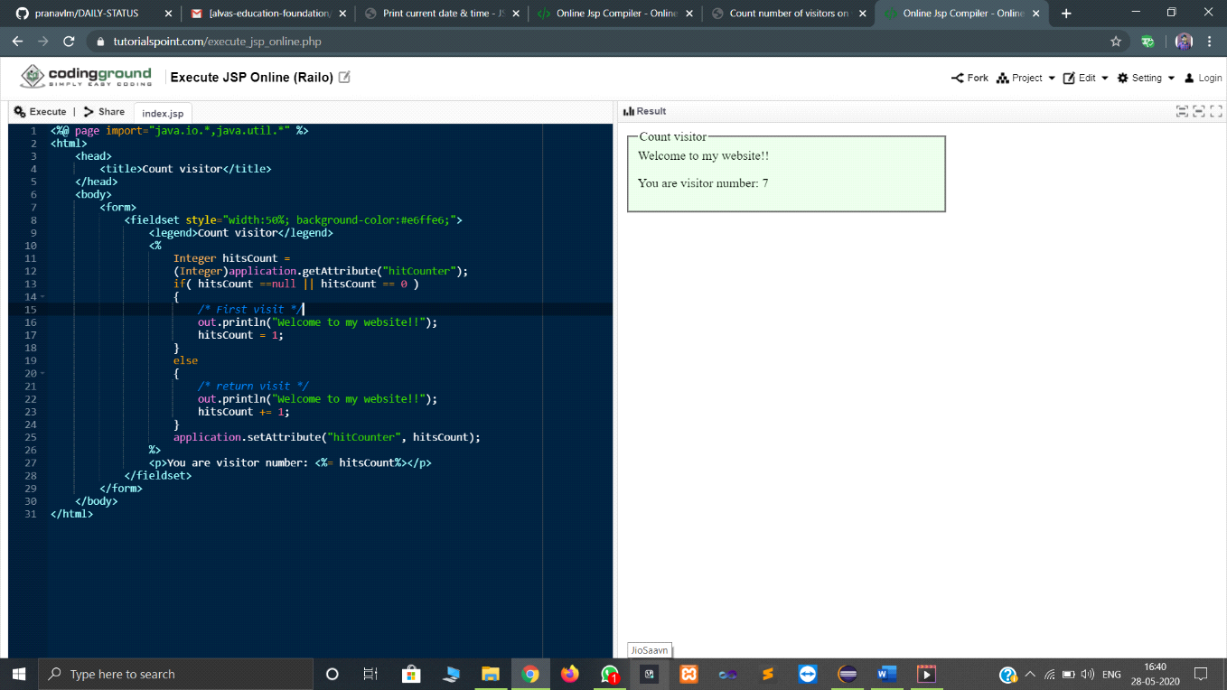

**Format for uploading details in Github and Slack in word file format**

**28/5/20**

**Student Name : Shrinivasa**

**Class and Sec : VI B**

**USN : 4AL17CS092**

|  |  |  |  |  |
| --- | --- | --- | --- | --- |
| **Online Test Details** | | | | |
| **Subject** | **Operating System** | | | |
| **Semester** | **VI - B** | | **Duration** | **50 Minutes** |
| **83%** | | **25/30** | | |

**Encl : snapshot of the test result**

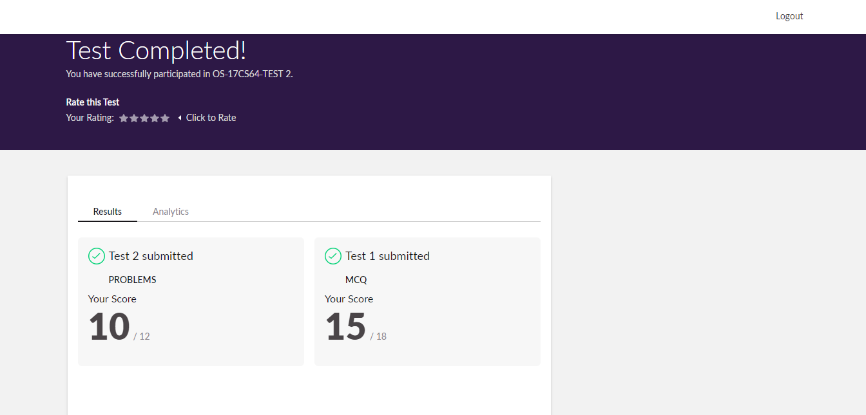

|  |  |  |  |
| --- | --- | --- | --- |
| **Certification Course Details** | | | |
| **Course** | **Blockchain Essentials** | | |
| **Certificate Provider** | **Cognitiveclass.ai** | **Duration** | **6 hours** |

**Encl : snapshots of the daily class acitivities (atleast two snap shots)**

**Progress on 28-05-2020**

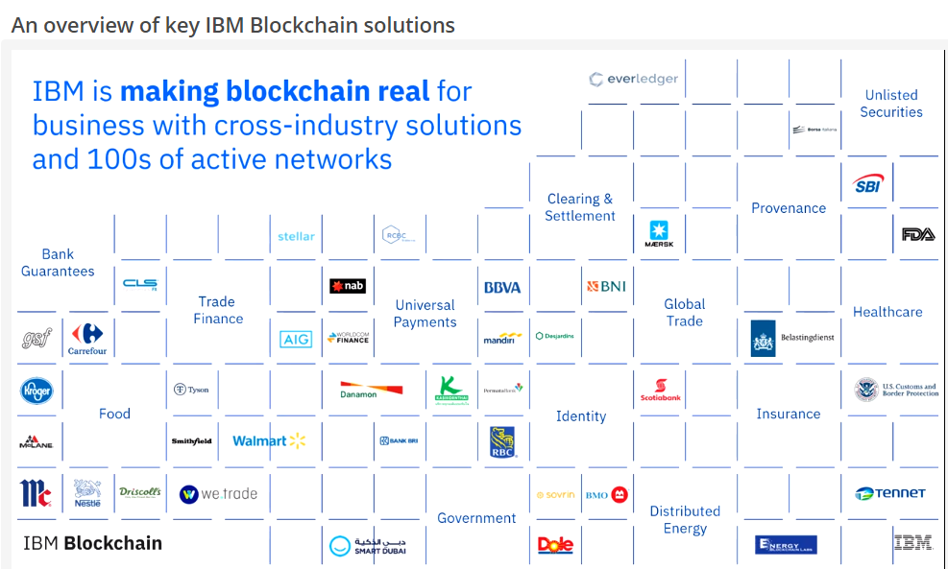

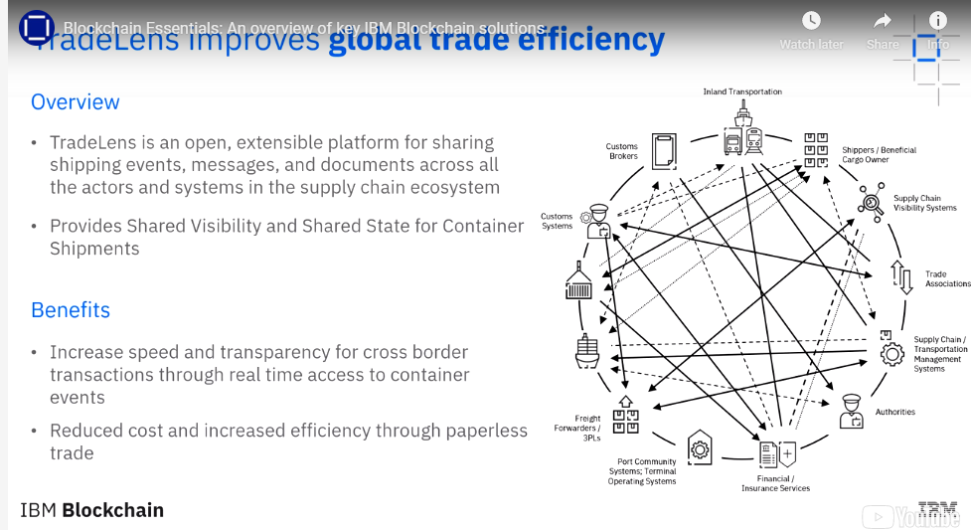

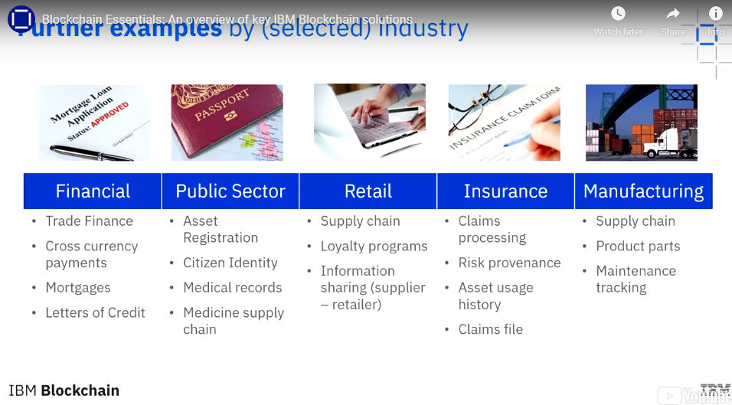

|  |  |
| --- | --- |
| **Coding Challenges** | |
| **Problem Statement:Pro1(python), Pro2(java), Pro3(java), Pro4(jsp), Pro5(jsp)**  **.** | |
| **Status: Completed** | |
| **Uploaded the report both in Github & Slack** | **Yes** |

**Encl : snapshots of your response to challenge.**

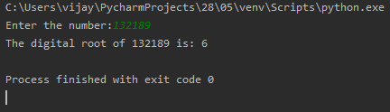

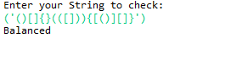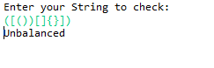

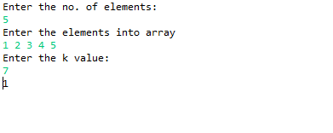

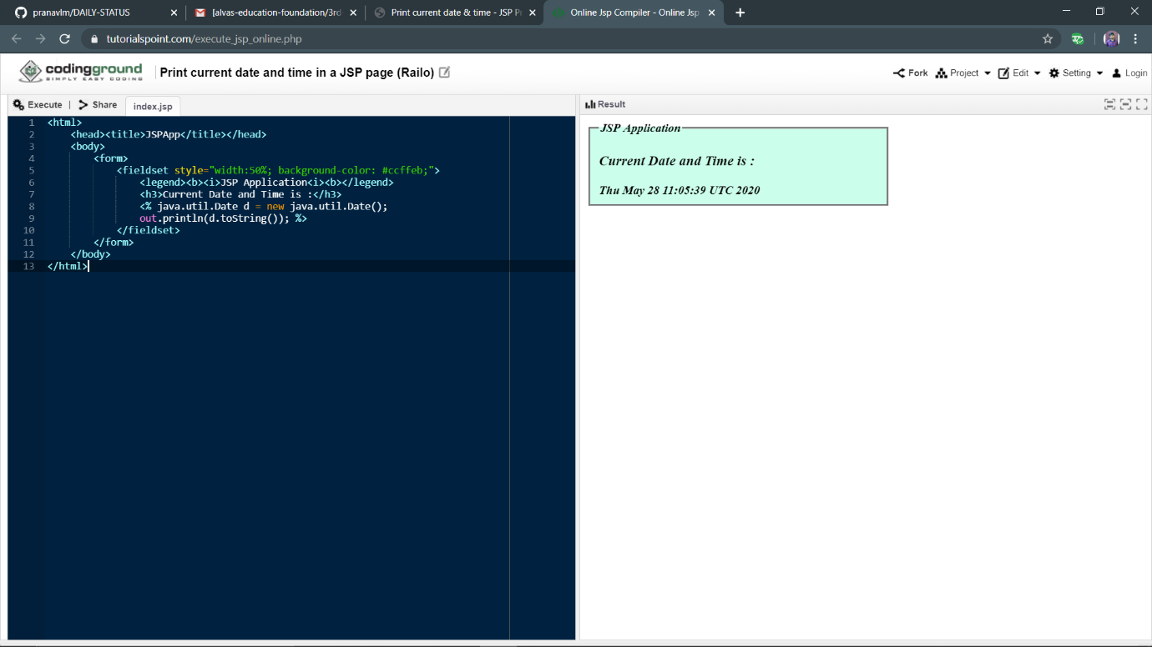

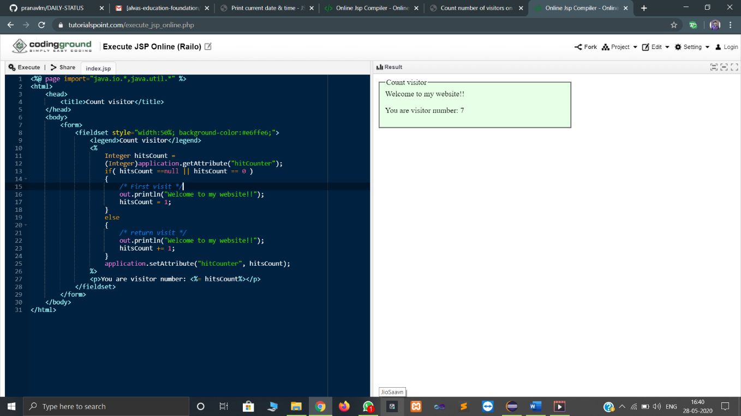

**DAILY ONLINE ACTIVITIES SUMMARY**

|  |  |  |  |  |  |  |  |  |  |  |
| --- | --- | --- | --- | --- | --- | --- | --- | --- | --- | --- |
| **Date:** | 28-05-2020 | | | | | | **Name:** | SHWETHA M S | | |
| **Sem & Sec** | 6th and B | | | | | | **USN:** | 4AL17CS093 | | |
| **Online Test Summary** | | | | | | | | | | |
| **Subject** | | OS (2ND IA TEST) | | | | | | | | |
| **Max. Marks** | | 30 | | **Score** | | | | | 23 | |
| **Certification Course Summary** | | | | | | | | | | |
| **Course** | PYTHON FOR MACHINE LEARNING | | | | | | | | | |
| **Certificate Provider** | | | Greatlearning academy | | **Duration** | | | | | 1 WEEK |
| **Coding Challenges** | | | | | | | | | | |
| **Problem Statement:** GIVEN 2 PROBLEMS | | | | | | | | | | |
| **Status:** Completed | | | | | | | | | | |
| **Uploaded the report in Github** | | | | | | Yes | | | | |
| **If yes Repository name** | | | | | | https://github.com/ShwethaKhadri/Shwetha-M-S.git | | | | |
| **Uploaded the report in slack** | | | | | | Shwetha M S  Yes, I uploaded the report in slack | | | | |

**SNAPSHOT OF SECOND IA TEST MARKS:**

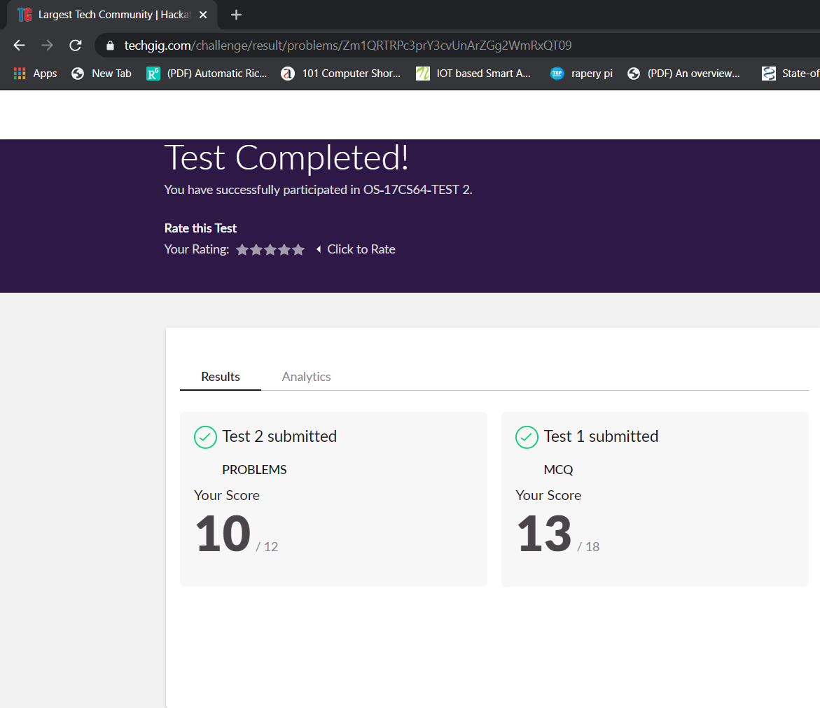

**SNAPSHOT OF ONLINE CERTIFICATION COURSE:**

**SCREENSHOT1:**

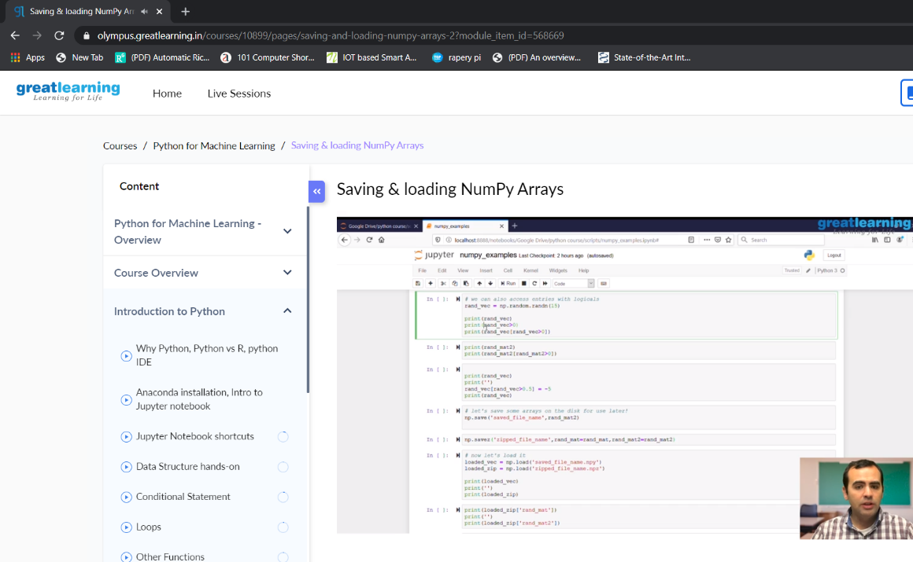

**SCREENSHOT2:**

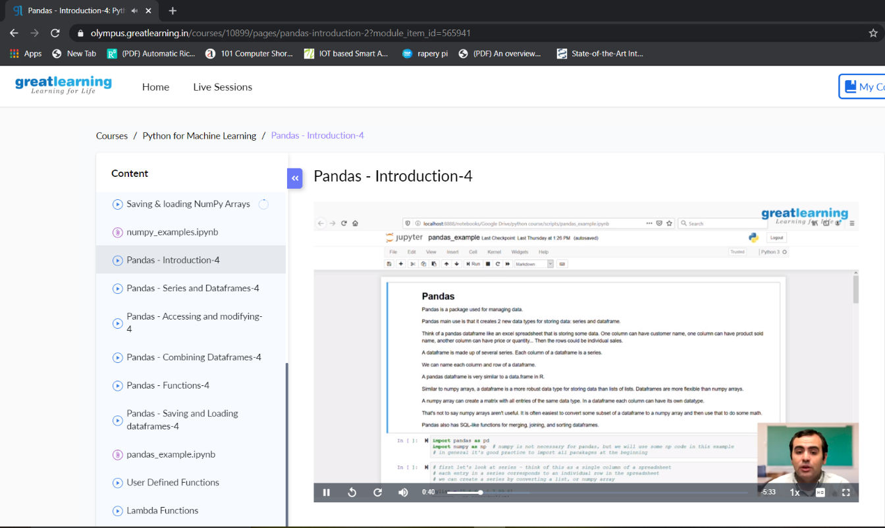

**SNAPSHOT OF ONLINE CODING:**

**PYTHON PROGRAM 1:**

A digital root is the recursive sum of all the digits in a number. Given n, take the sum of the digits of n. If that value has more than one digit, continue reducing in this way until a single-digit number is produced. This is only applicable to the natural numbers.

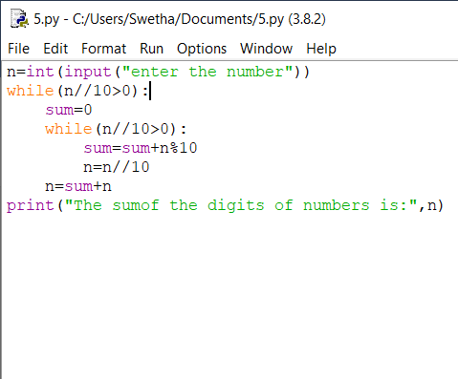

**OUTPUT:**

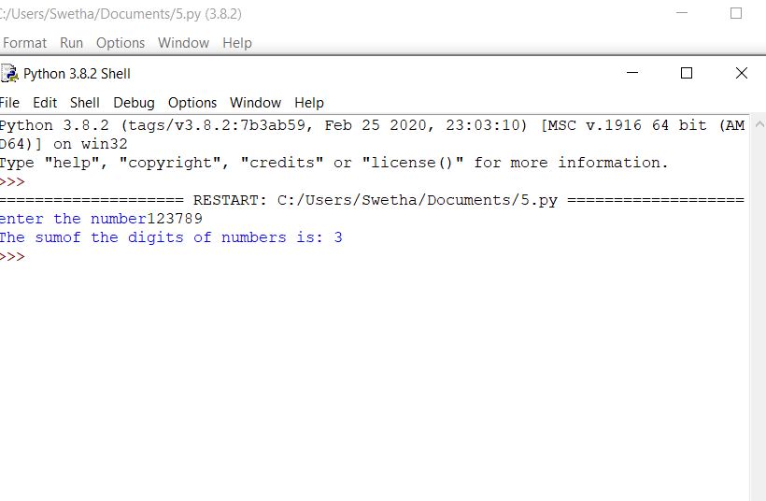

**C++ PROGRAM:**

The rules for reducing the array are:  
#The first and last element say X and Y are chosen and removed from the array arr[].  
#The values X and Y are added. Z = X + Y.  
#Insert the value of Z % K into the array arr[] at the position ((N/2) + 1)th position, where N denotes the current length of the array.  
Examples:

Input: N = 5, arr[] = {1, 2, 3, 4, 5}, K = 7  
Output: 1

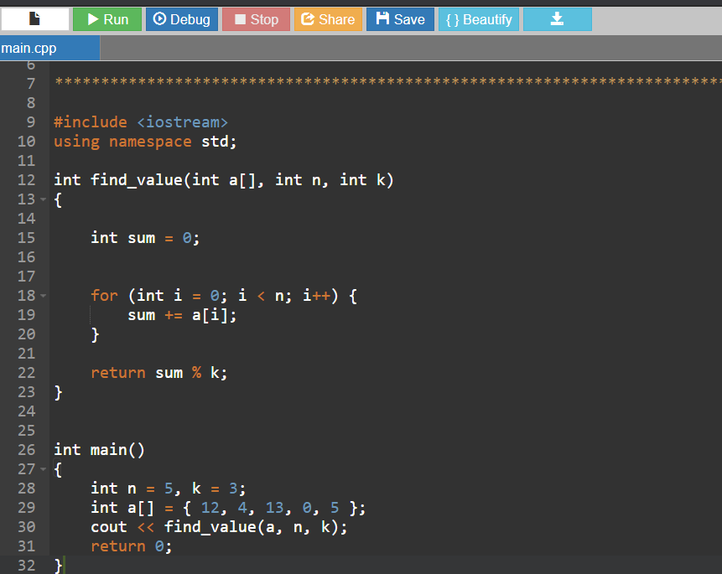

**OUTPUT:**

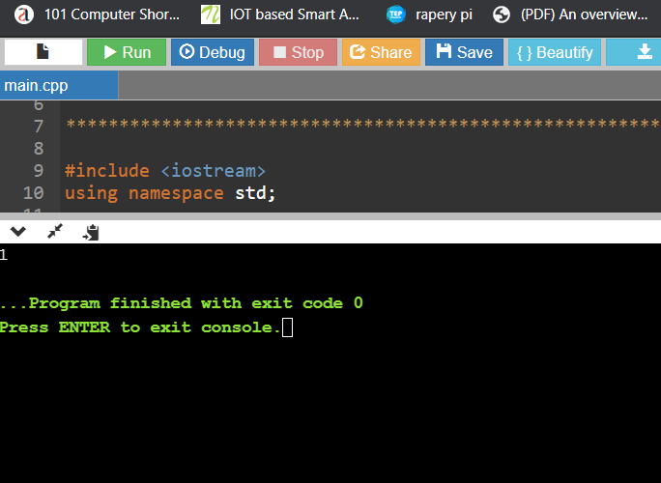

**DAILY ONLINE ACTIVITIES SUMMARY**

|  |  |  |  |  |  |  |  |  |  |  |
| --- | --- | --- | --- | --- | --- | --- | --- | --- | --- | --- |
| **Date:** | 28-05-2020 | | | | | | **Name:** | SINDHU N | | |
| **Sem & Sec** | 6th and B | | | | | | **USN:** | 4AL17CS094 | | |
| **Online Test Summary** | | | | | | | | | | |
| **Subject** | | OS (2ND IA TEST) | | | | | | | | |
| **Max. Marks** | | 30 | | **Score** | | | | | 24 | |
| **Certification Course Summary** | | | | | | | | | | |
| **Course** | PYTHON FOR MACHINE LEARNING | | | | | | | | | |
| **Certificate Provider** | | | Greatlearning academy | | **Duration** | | | | | 1 WEEK |
| **Coding Challenges** | | | | | | | | | | |
| **Problem Statement:** GIVEN 2 PROBLEMS | | | | | | | | | | |
| **Status:** Completed | | | | | | | | | | |
| **Uploaded the report in Github** | | | | | | Yes | | | | |
| **If yes Repository name** | | | | | | https://github.com/lsindhungowda/Daily-report | | | | |
| **Uploaded the report in slack** | | | | | | Sindhu N  Yes, I uploaded the report in slack | | | | |

**SNAPSHOT OF SECOND IA TEST MARKS:**

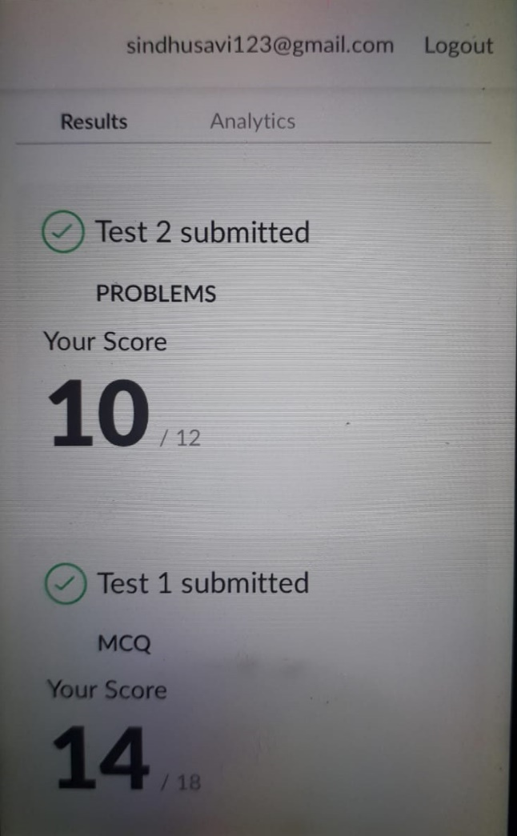

**SNAPSHOT OF ONLINE CERTIFICATION COURSE:**

**SCREENSHOT1:**



**SCREENSHOT2:**



**SNAPSHOT OF ONLINE CODING:**

**PYTHON PROGRAM 1:**

A digital root is the recursive sum of all the digits in a number. Given n, take the sum of the digits of n. If that value has more than one digit, continue reducing in this way until a single-digit number is produced. This is only applicable to the natural numbers.



**OUTPUT:**



**C++ PROGRAM:**

The rules for reducing the array are:  
#The first and last element say X and Y are chosen and removed from the array arr[].  
#The values X and Y are added. Z = X + Y.  
#Insert the value of Z % K into the array arr[] at the position ((N/2) + 1)th position, where N denotes the current length of the array.  
Examples:

Input: N = 5, arr[] = {1, 2, 3, 4, 5}, K = 7  
Output: 1



**OUTPUT:**



**DAILY ONLINE ACTIVITIES SUMMARY**

|  |  |  |  |  |  |  |  |  |
| --- | --- | --- | --- | --- | --- | --- | --- | --- |
| **Date:** | **28/05/2020** | | | | | **Name:** | **Soundarya R** | |
| **Sem & Sec** | **6th & B** | | | | | **USN:** | **4al17cs096** | |
| **Online Test Summary** | | | | | | | | |
| **Subject** | | **OS** | | | | | | |
| **Max. Marks** | | **30** | | **Score** | | | **16** | |
| **Certification Course Summary** | | | | | | | | |
| **Course** | **Python for Machine Learning** | | | | | | | |
| **Certificate Provider** | | | **Great Learning Academy** | | **Duration** | | | **5hours** |
| **Coding Challenges** | | | | | | | | |
| **Problem Statement:** 2Programs | | | | | | | | |
| **Status: Solved** | | | | | | | | |
| **Uploaded the report in Github** | | | | | **yes** | | | |
| **If yes Repository name** | | | | | <https://github.com/ashu102/Daily-Activities> | | | |
| **Uploaded the report in slack** | | | | | **yes** | | | |

IA TEST

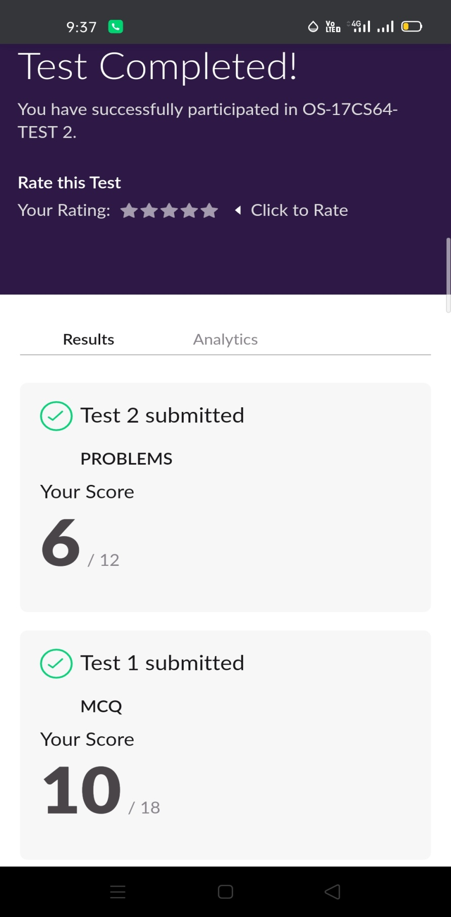

CERTIFICATION COURSE

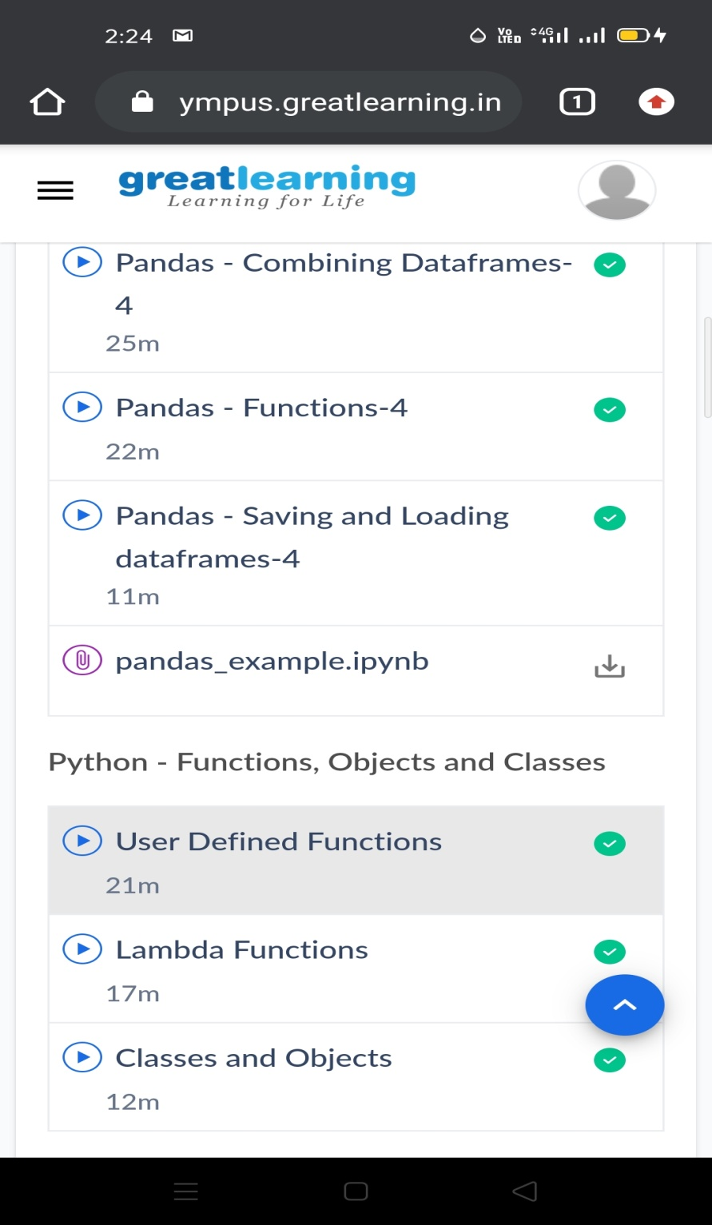

ONLINE CODING

Program:

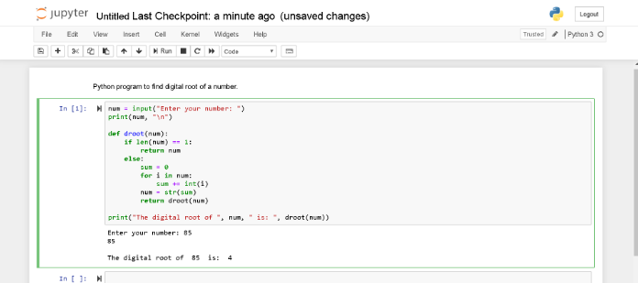

**DAILY ONLINE ACTIVITIES SUMMARY**

|  |  |  |  |  |  |  |  |  |
| --- | --- | --- | --- | --- | --- | --- | --- | --- |
| **Date:** | **28-05-2020** | | | | | **Name:** | **SRILATHA K KAMATH** | |
| **Sem & Sec** | **6 B** | | | | | **USN:** | **4AL17CS099** | |
| **Online Test Summary** | | | | | | | | |
| **Subject** | | **Operating Systems IA TEST 2** | | | | | | |
| **Max. Marks** | | **30** | | **Score** | | | **24** | |
| **Certification Course Summary** | | | | | | | | |
| **Course** | **Career Edge – Knockdown the Lockdown** | | | | | | | |
| **Certificate Provider** | | | **TCS** | | **Duration** | | | **15days** |
| **Coding Challenges** | | | | | | | | |
| **Problem Statement:** Given n, take the sum of the digits of n. If that value has more than one digit, continue reducing in this way until a single-digit number is produced. This is only applicable to the natural numbers. | | | | | | | | |
| **Status: COMPLETED** | | | | | | | | |
| **Uploaded the report in Github** | | | | | **YES** | | | |
| **If yes Repository name** | | | | | https://github.com/alvas-education-foundation/Srilatha-K-Kamath-Daily-Report.git | | | |
| **Uploaded the report in slack** | | | | | **YES** | | | |

Online Test Details:

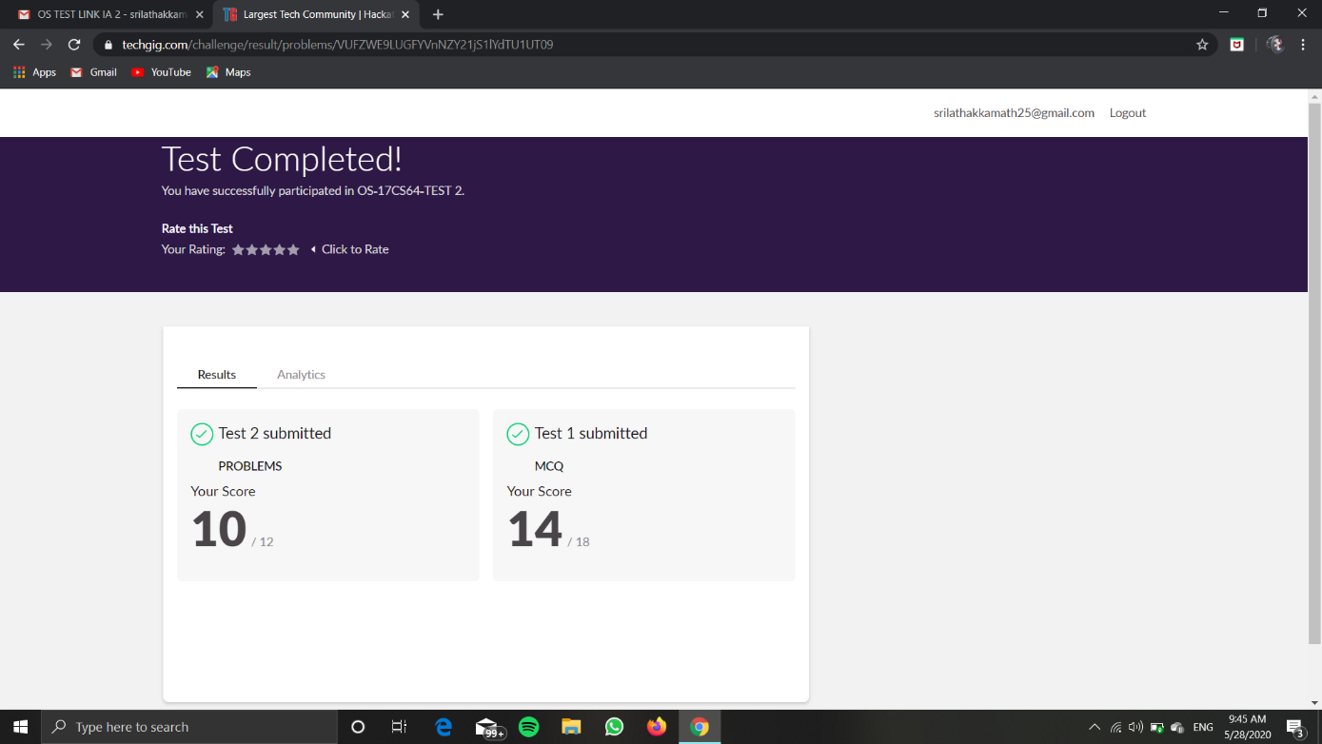

Online Course Details: Completed Course and obtained the certificate.

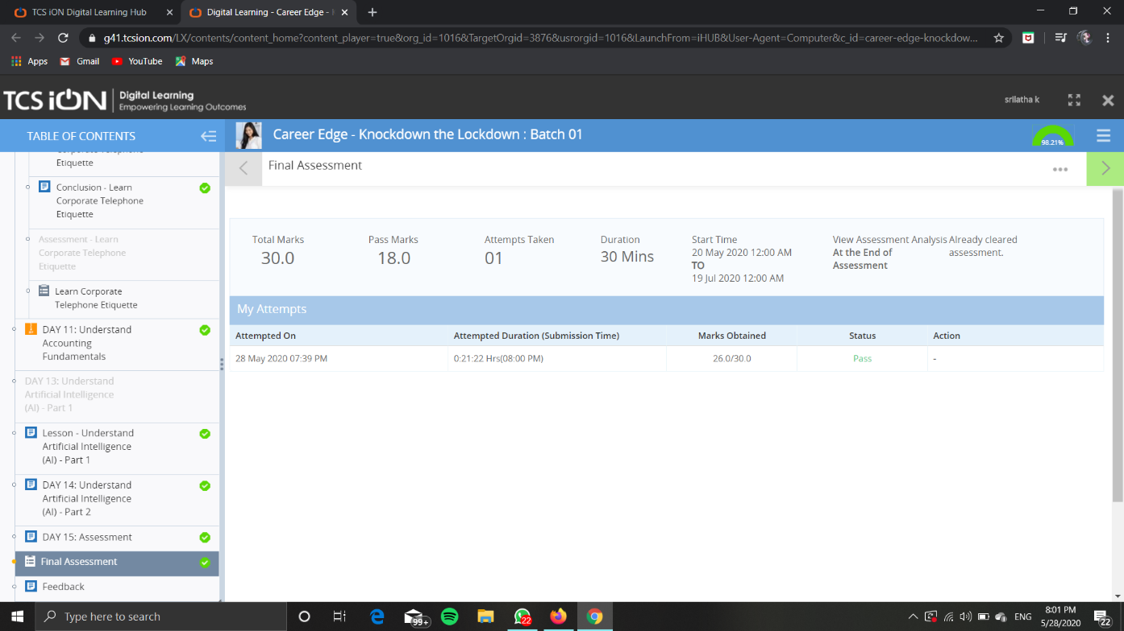

Posted the certificate in github repository.

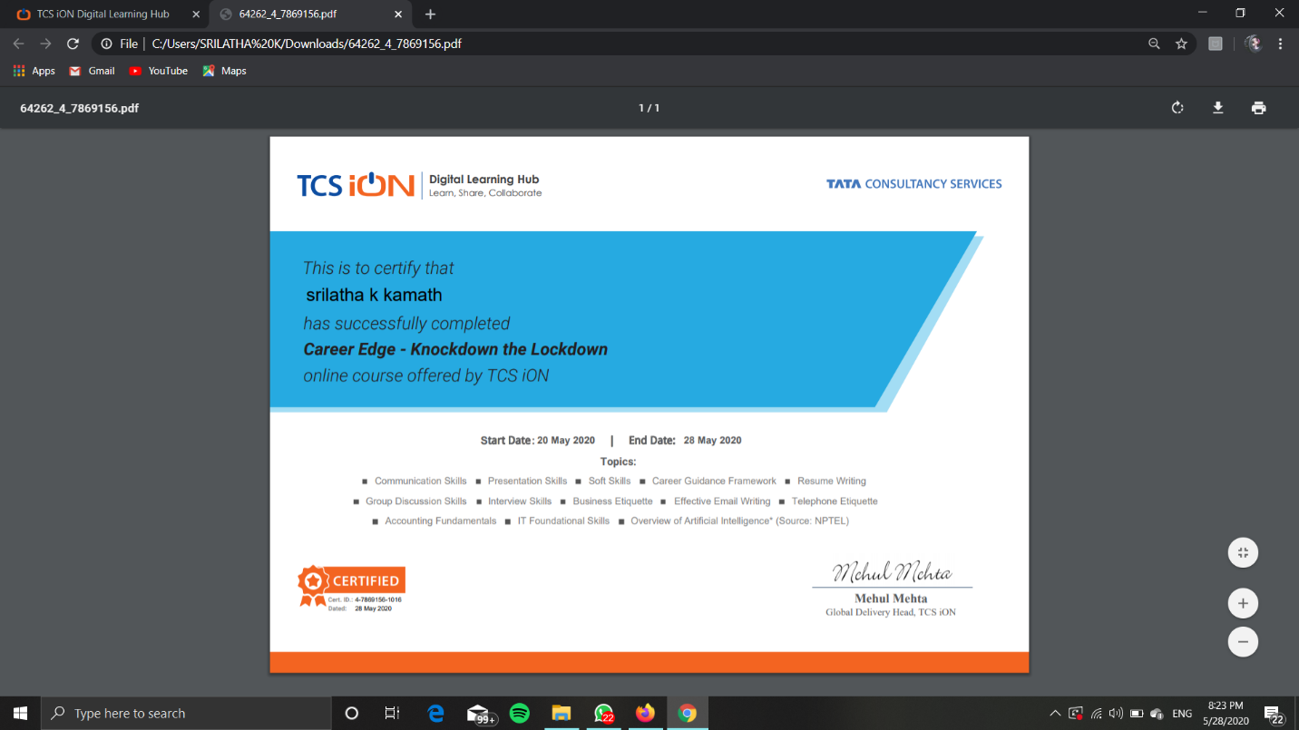

Online Coding Details: 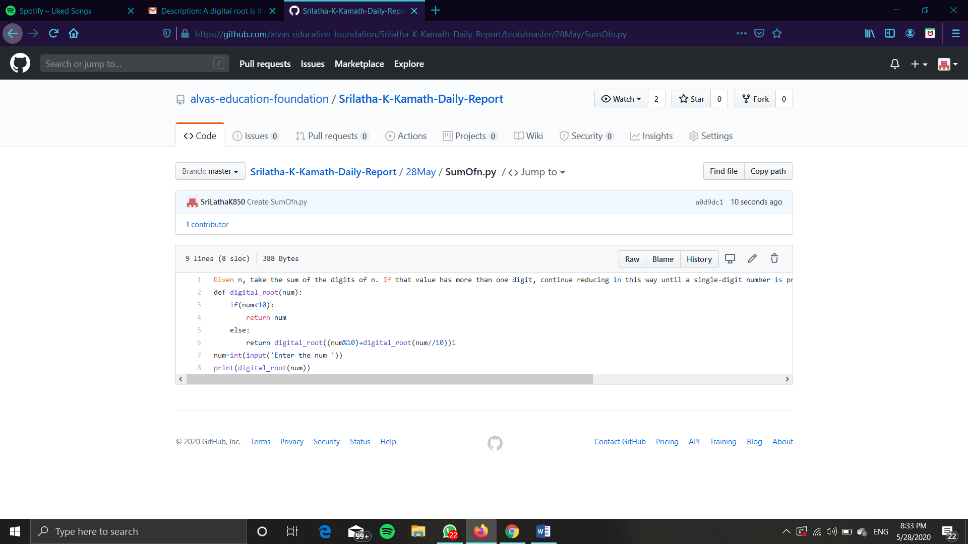



**Format for uploading details in Github and Slack in word file format**

**28/5/20**

**Student Name : Suhas M S**

**Class and Sec : VI B**

**USN : 4AL17CS100**

|  |  |  |  |  |
| --- | --- | --- | --- | --- |
| **Online Test Details** | | | | |
| **Subject** | **Operating System** | | | |
| **Semester** | **VI - B** | | **Duration** | **50 Minutes** |
| **73%** | | **22/30** | | |

**Encl : snapshot of the test result**



|  |  |  |  |
| --- | --- | --- | --- |
| **Certification Course Details** | | | |
| **Course** | **Blockchain Essentials** | | |
| **Certificate Provider** | **Cognitiveclass.ai** | **Duration** | **6 hours** |

**Encl : snapshots of the daily class acitivities (atleast two snap shots)**

**Progress on 28-05-2020**







|  |  |
| --- | --- |
| **Coding Challenges** | |
| **Problem Statement:Pro1(python), Pro2(java), Pro3(java), Pro4(jsp), Pro5(jsp)**  **.** | |
| **Status: Completed** | |
| **Uploaded the report both in Github & Slack** | **Yes** |

**Encl : snapshots of your response to challenge.**











**Format for uploading details in Github and Slack in word file format**

**(Fill this format(docx) daily and upload it in both Github and Slack)**

**28/5/20**

**Student Name : SURYA PRAKASH S**

**Class and Sec : VI B**

**USN : 4AL17CS101**

|  |  |  |  |  |
| --- | --- | --- | --- | --- |
| **Online Test Details** | | | | |
| **Subject** | **Operating System** | | | |
| **Semester** | **VI -B** | | **Duration** | **35 Minutes** |
| **% of marks** | | **80** | | |

**Encl : snapshot of the test result**

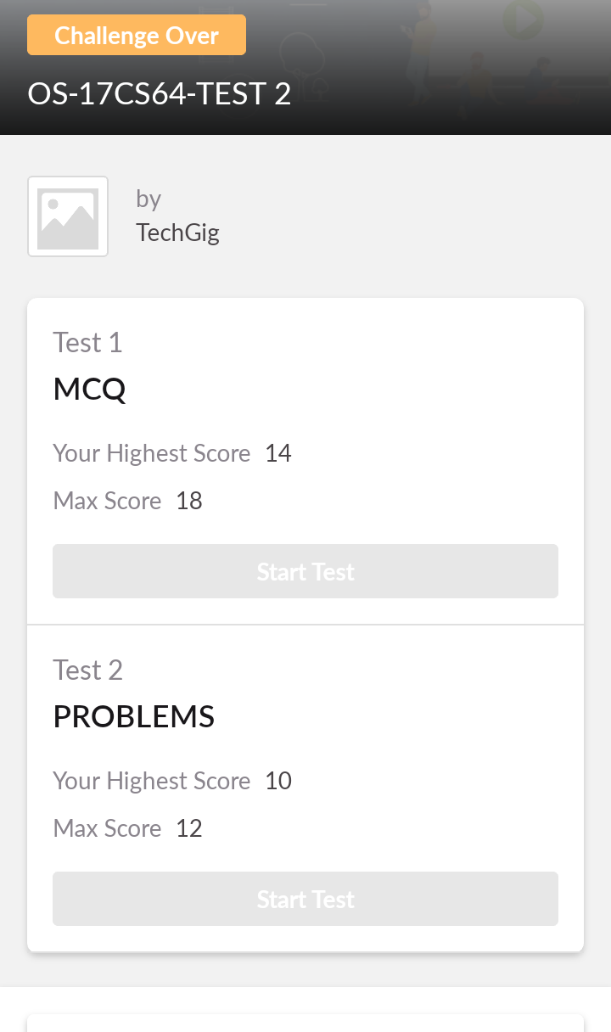

|  |  |  |  |
| --- | --- | --- | --- |
| **Certification Course Details** | | | |
| **Course** | **Python for Data Science** | | |
| **Certificate Provider** | **Cognitiveclass.ai** | **Duration** | **06 hours** |

**Encl : snapshots of the daily class acitivities (atleast two snap shots)**

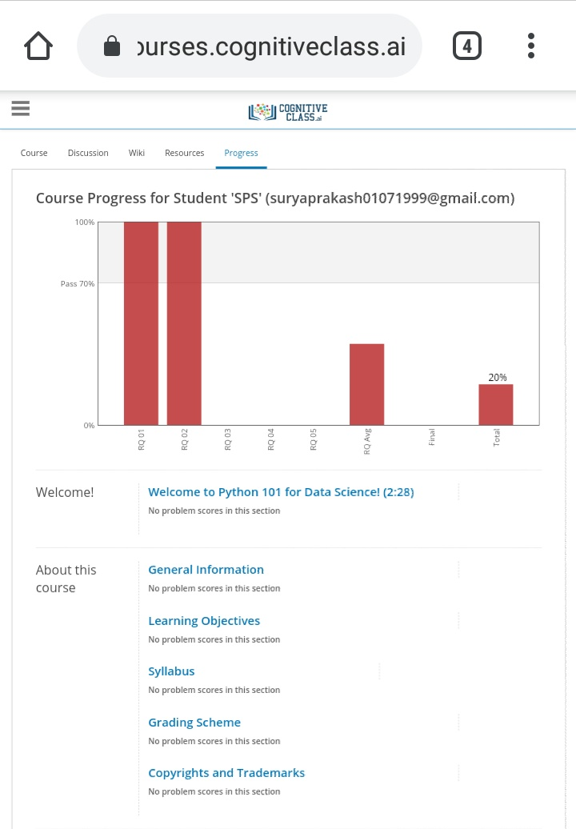

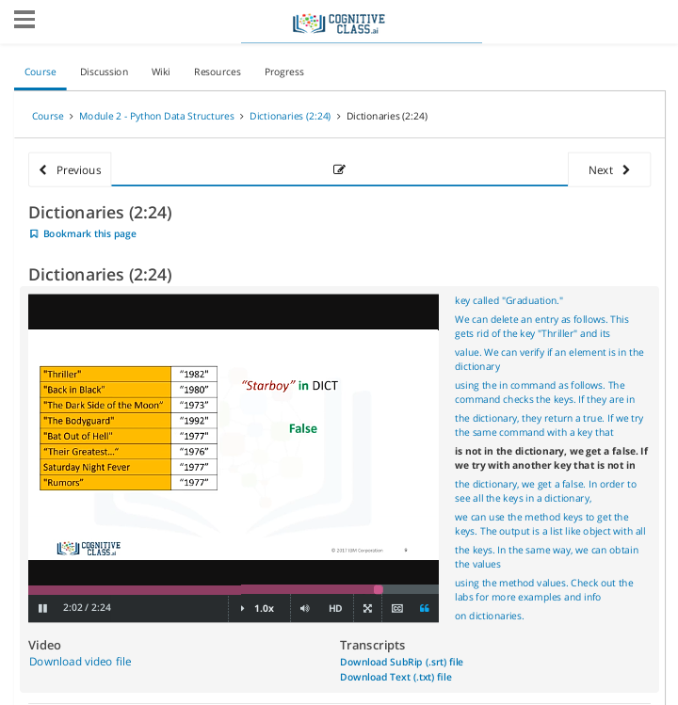

|  |  |
| --- | --- |
| **Coding Challenges** | |
| **Problem Statement: 1. Bubble sort 2. Binary tree 3. Array 4. JSP for date and time 5. JSP for visitors** | |
| **Status: Completed** | |
| **Uploaded the report both in Github & Slack** | **Yes** |

**Encl : snapshots of your response to challenge.**



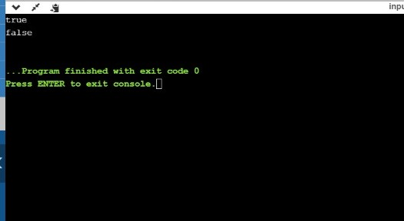

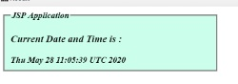

https://github.com/SPSSURYA/Online-Coding-And-Certification-Course

**DAILY ONLINE ACTIVITIES SUMMARY**

|  |  |  |  |  |  |  |  |  |
| --- | --- | --- | --- | --- | --- | --- | --- | --- |
| **Date:** | **28-05-2020** | | | | | **Name:** | **sushmitha** | |
| **Sem & Sec** | **6TH & B** | | | | | **USN:** | **4al17cs102** | |
| **Online Test Summary** | | | | | | | | |
| **Subject** | | **OS** | | | | | | |
| **Max. Marks** | | **30** | | **Score** | | | **26** | |
| **Certification Course Summary** | | | | | | | | |
| **Course** | **Python for machine learning** | | | | | | | |
| **Certificate Provider** | | | **IBM** | | **Duration** | | | **12 hrs** |
| **Coding Challenges** | | | | | | | | |
| **Problem Statement:1 java program** | | | | | | | | |
| **Status:done** | | | | | | | | |
| **Uploaded the report in Github** | | | | | **yes** | | | |
| **If yes Repository name** | | | | | <https://github.com/sushmithaganiga/Report> | | | |
| **Uploaded the report in slack** | | | | | **yes** | | | |

Online Test Details: (Attach the snapshot and briefly write the report for the same)

Certification Course Details: (Attach the snapshot and briefly write the report for the same)

Coding Challenges Details: (Attach the snapshot and briefly write the report for the same)

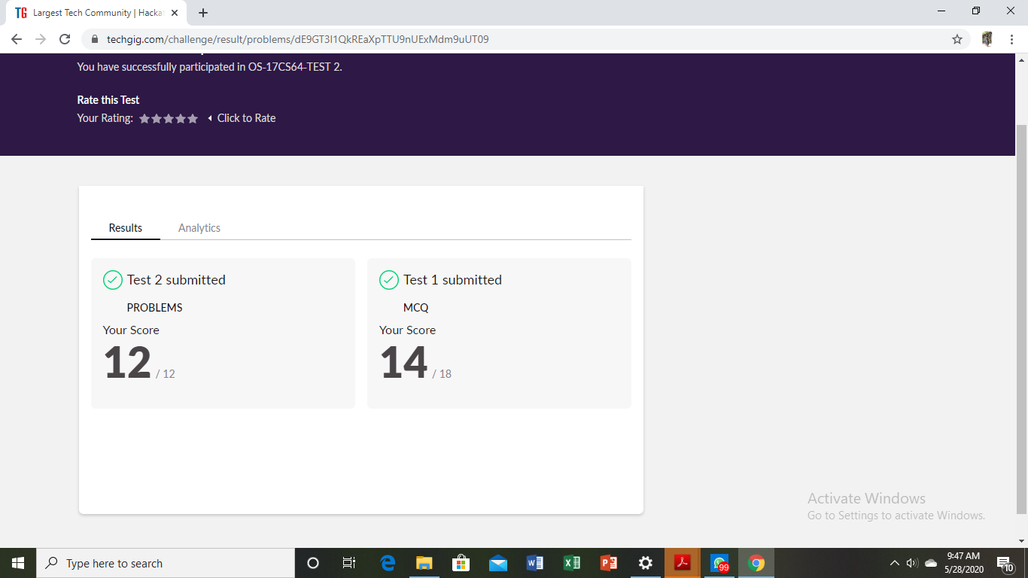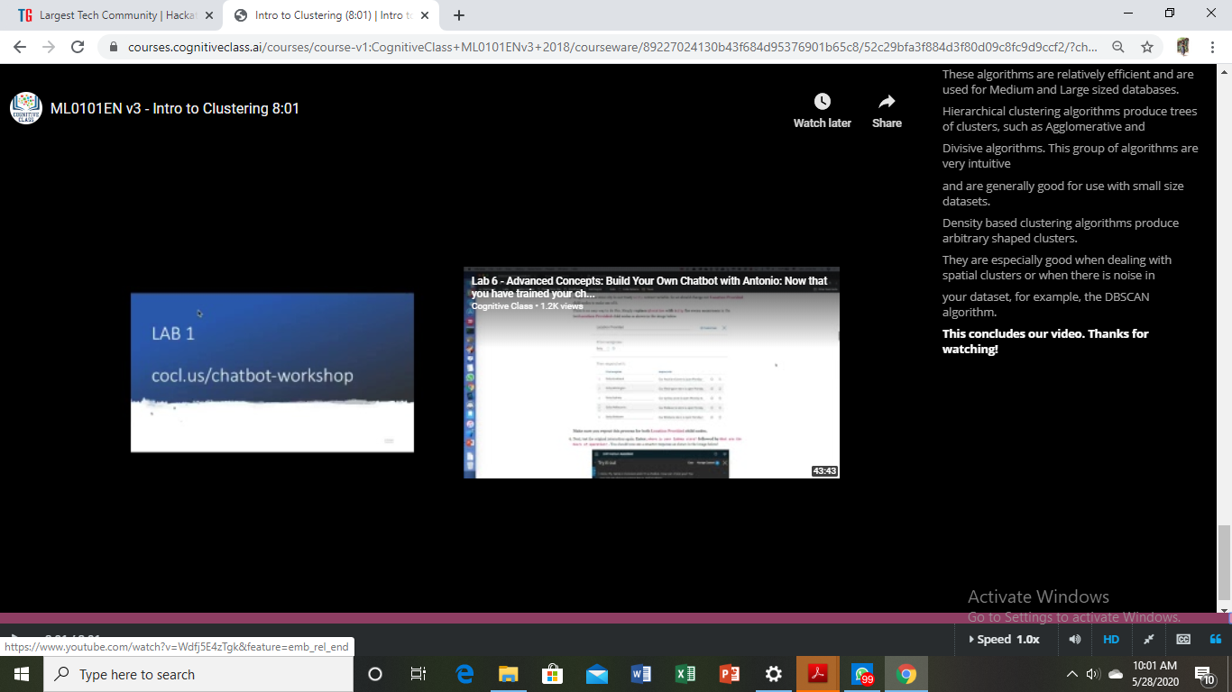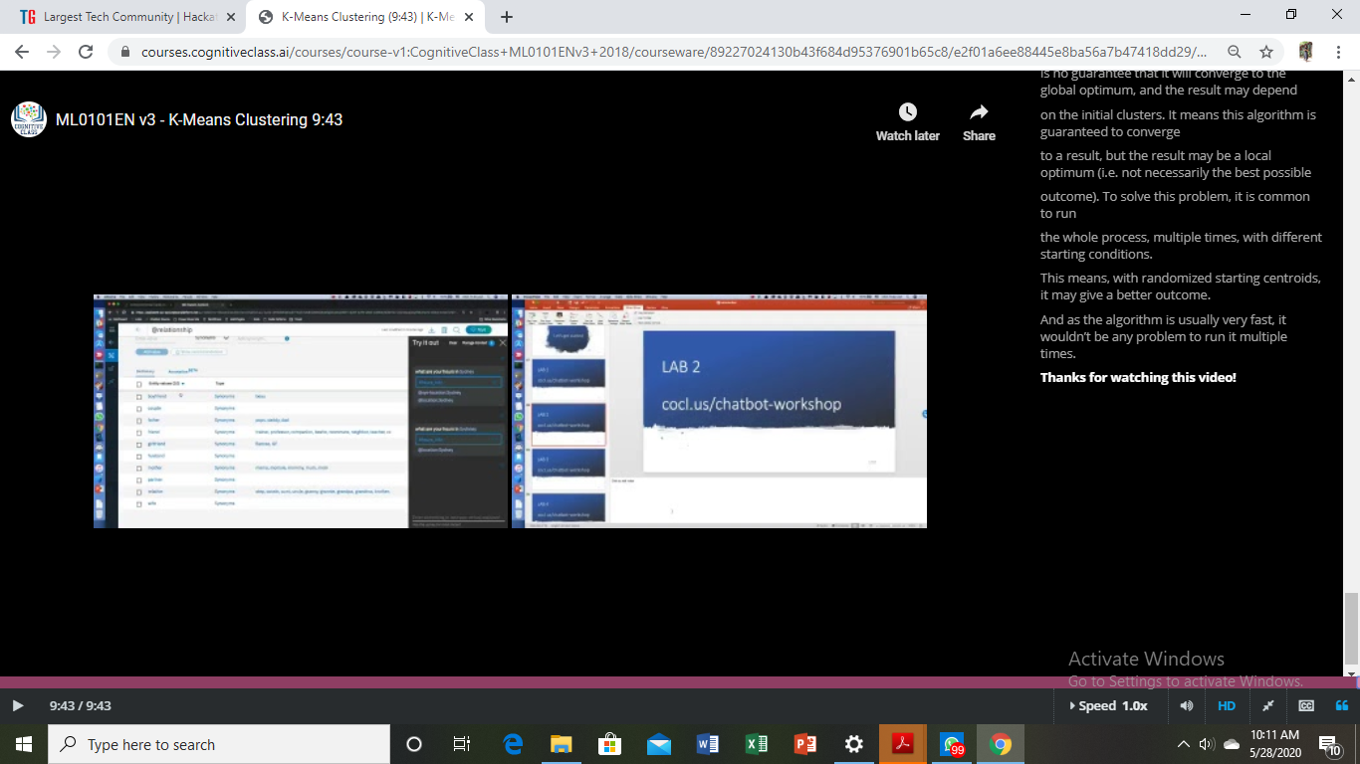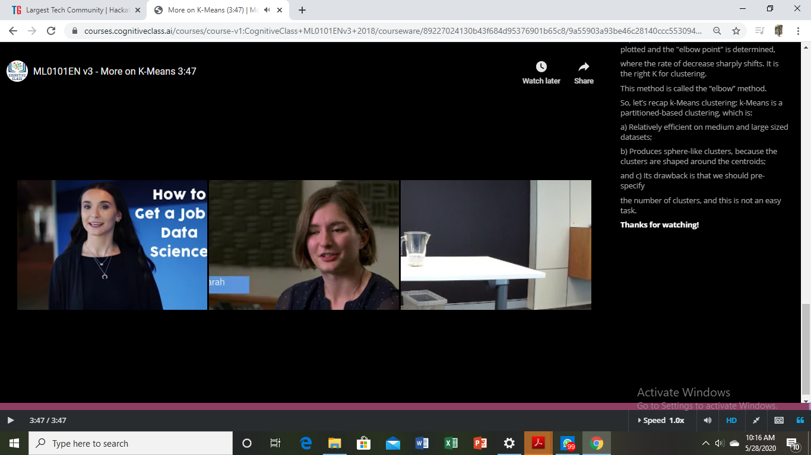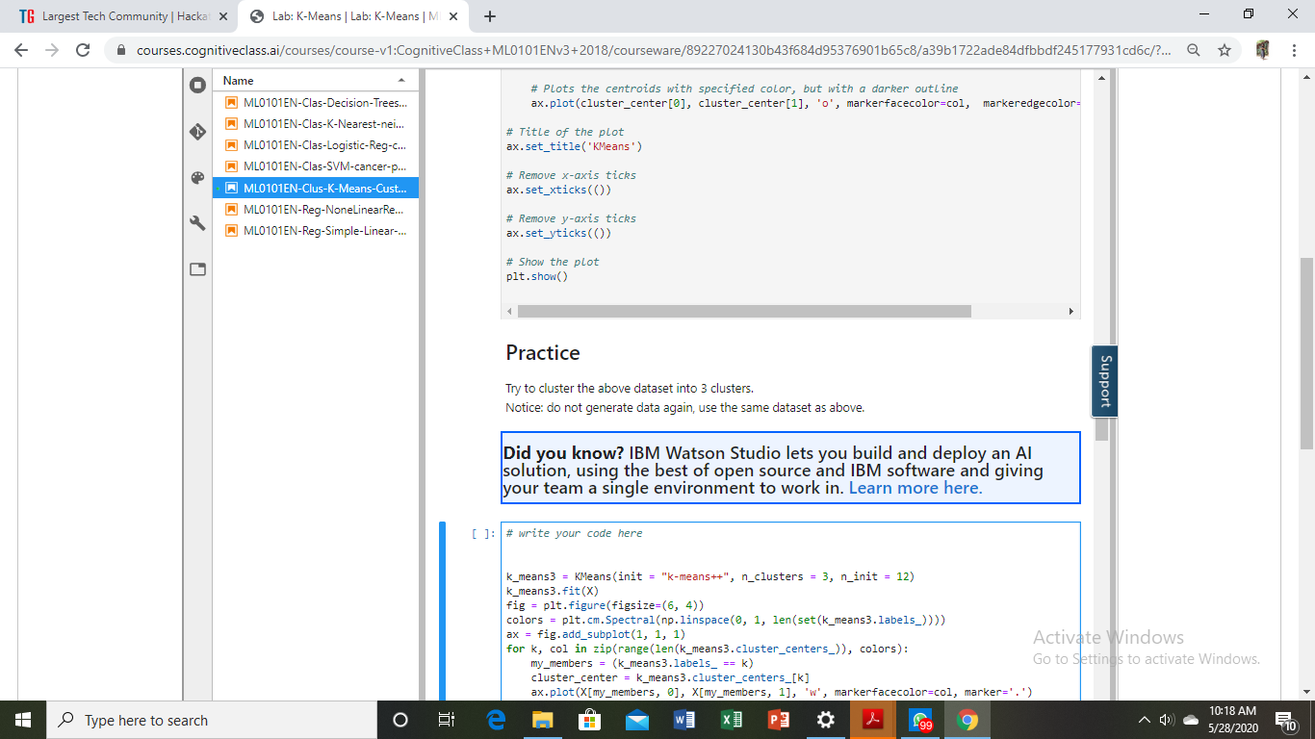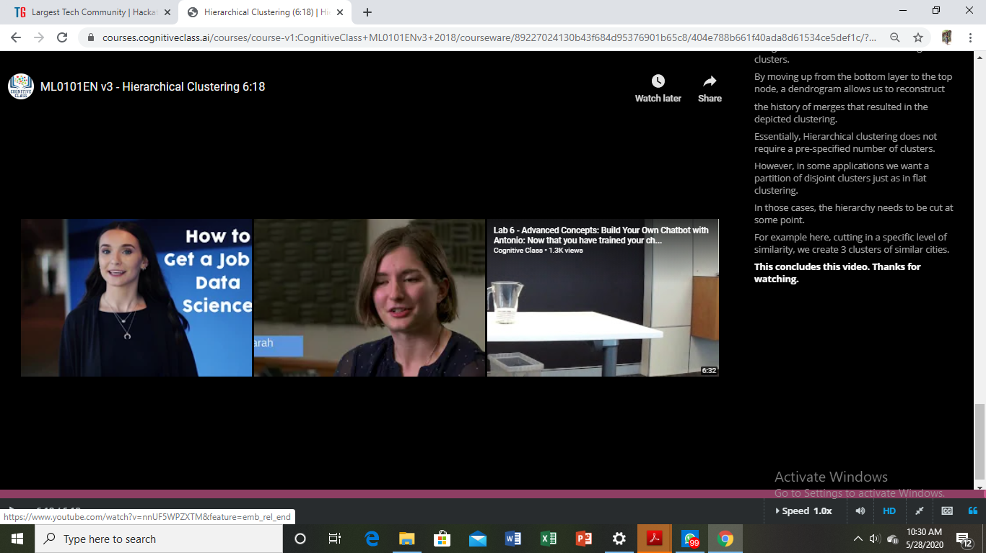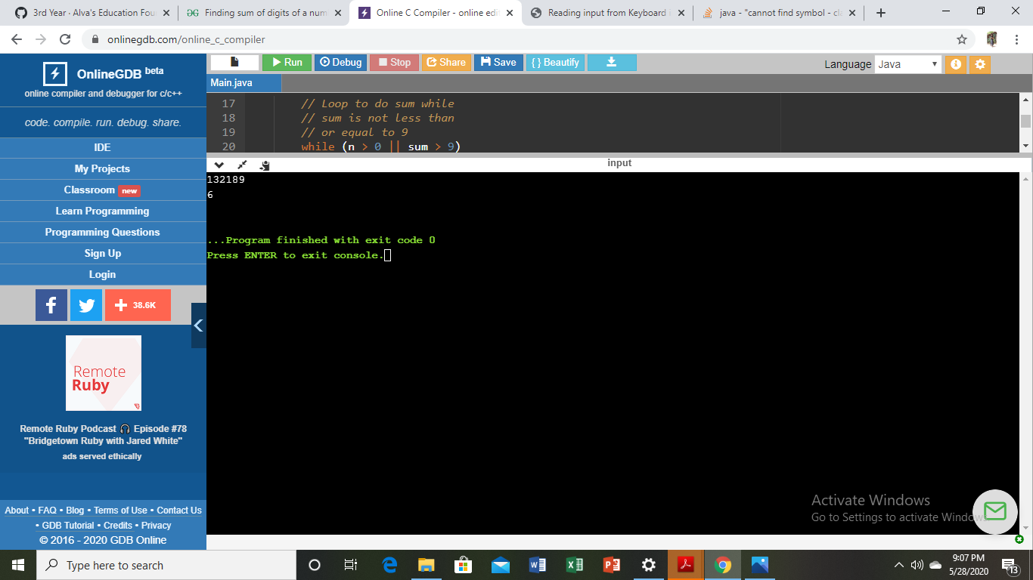

**DAILY REPORT**

**28/5/20**

**Student Name :SUSHMITHA B POOJARY**

**Class and Sec : VI B**

**USN :4AL17CS103**

**Date:28-05-2020**

|  |  |  |  |  |
| --- | --- | --- | --- | --- |
| **Online Test Details** | | | | |
| **Subject** | **Operating system** | | | |
| **Semester** | **VI B** | | **Duration** | **35 Minutes** |
| **% of marks 30** | | **16** | | |

**snapshot of the test result**

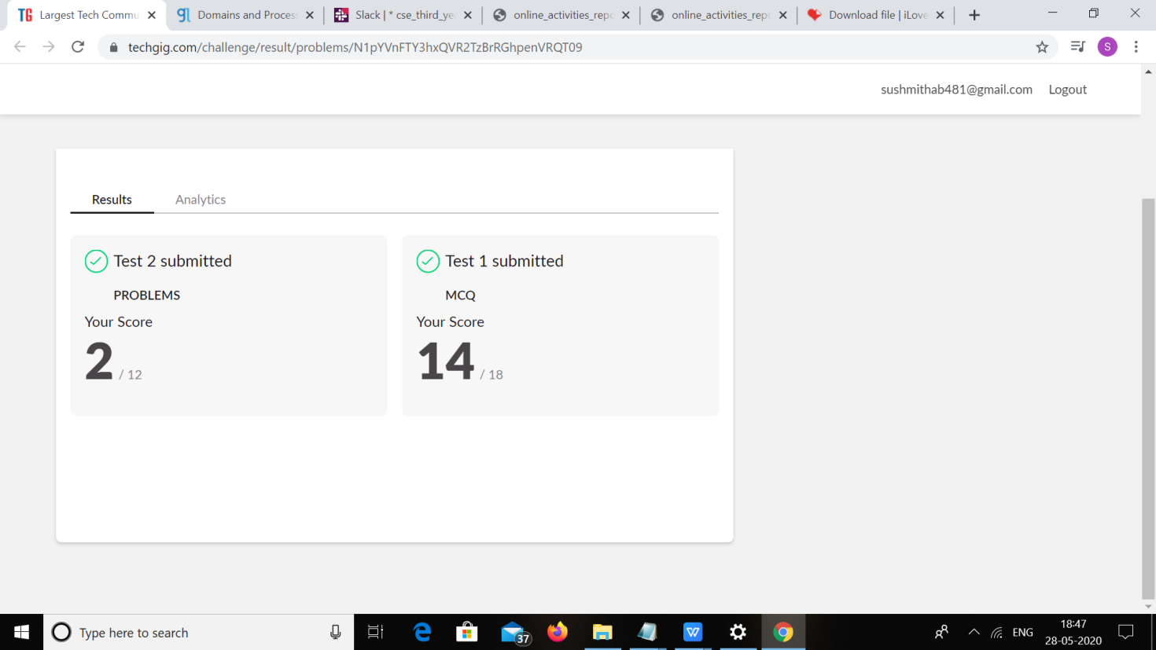

|  |  |  |  |
| --- | --- | --- | --- |
| **Certification Course Details** | | | |
| **Course** | **Ethical Hacking** | | |
| **Certificate Provider** | **Great learning** | **Duration** | **6hours** |

**snapshots of the daily class acitivities**

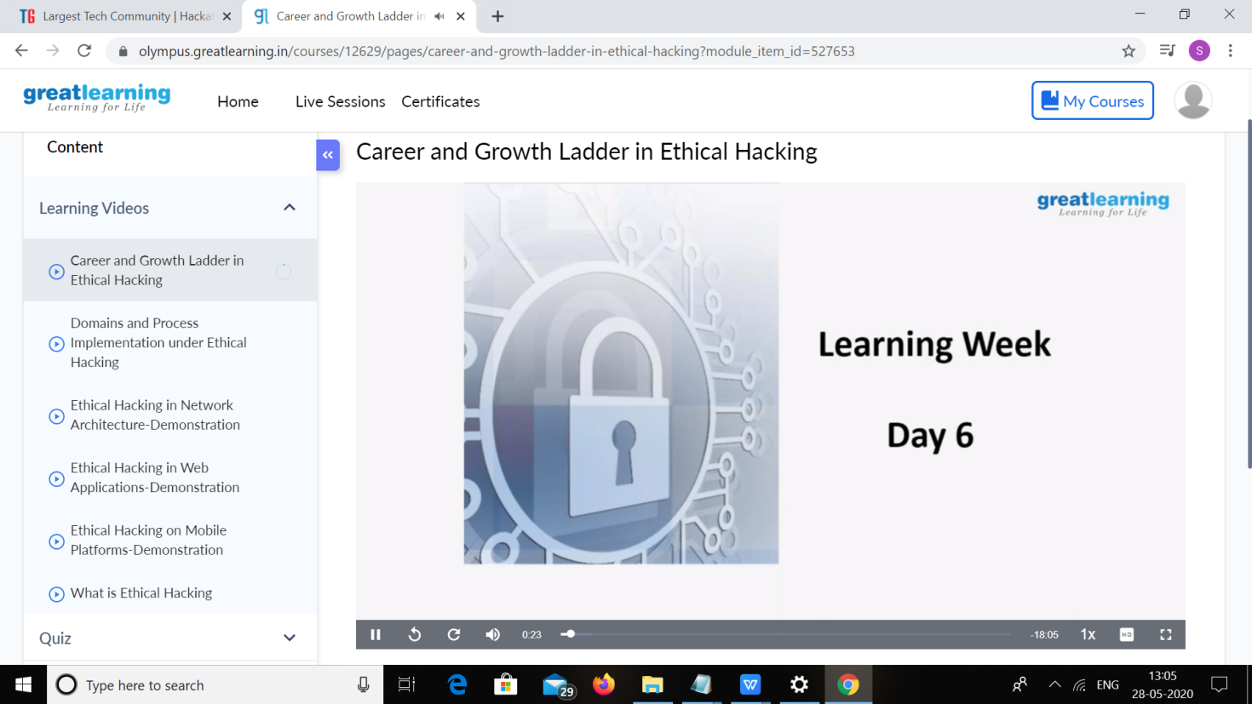

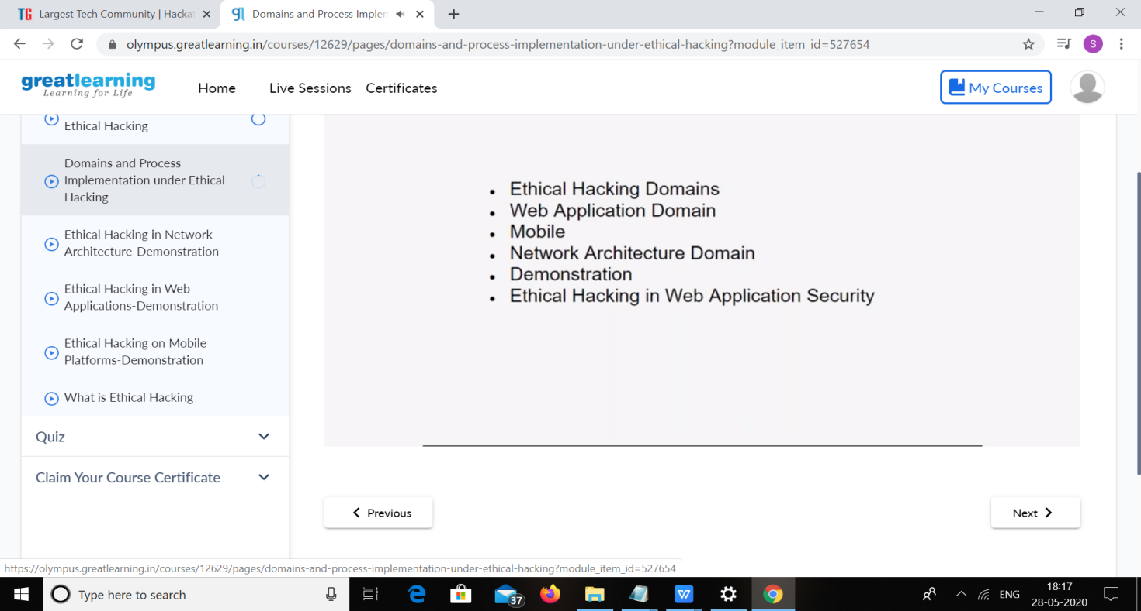

|  |  |
| --- | --- |
| **Coding Challenges** | |
| **1.Problem Statement:** Python program to find digital root of a number  JAVA PROGRM-BALANCED BRAKET | |
| **Status: Executed** | |
| **Uploaded the report both in Github & Slack** | **yes** |

**snapshots of response to challenge.**

**Coding Challenges Details:**

1. Python program to find digital root of a number

Description:

A digital root is the recursive sum of all the digits in a number. Given n, take the sum of the digits of n. If that value has more than one digit, continue reducing in this way until a single-digit number is produced. This is only applicable to the natural numbers.

digit_root(0)= 0

digital_root(16)

=> 1 + 6

=> 7

digital_root(132189)

=> 1 + 3 + 2 + 1 + 8 + 9

=> 24 ...

=> 2 + 4

=> 6

def DigitalRoot(number): addper=0

while number >=10:

number = sum(int(digit)for digit in str(number))

addper +=1

#I highly recommend using return instead of print, but for testing purposes I used print

print(number) DigitalRoot(132189)

**Output**

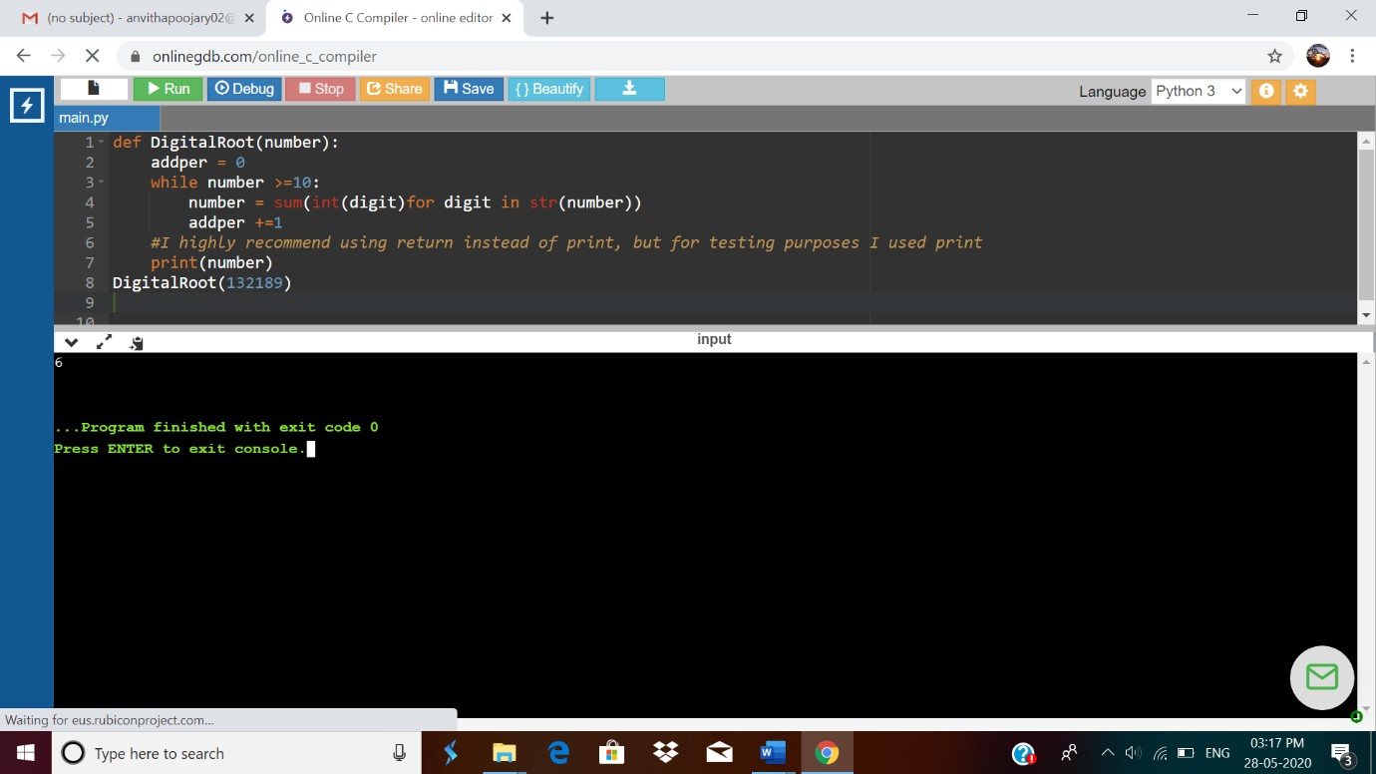

1. JAVA PROGRM-BALANCED BRAKET

Write a function that accepts a string consisting entiring of brackets ({}) and returns whether it is balanced. Every "opening" bracket must be followed by a closing bracket of the same type. There can also be nested brackets, which adhere to the same rule. f('()[]{}(([])){[()][]}') // true

f('())[]{}') // false

import java.util.Stack; public class Main {

public static void main(String[] args)

{

System.out.println(is_parentheses_balanced("()[]{}(([])){[()][]}"));

}

public static boolean matchingPeer(char open , char close){

if ( open == '(' && close == ')')

{

return true;

}

if ( open == '[' && close == ']')

{

return true;

}

else{

return false;

}

}

public static boolean is_parentheses_balanced(String equation){

char[] c = equation.toCharArray();

Stack <Character> myStack= new Stack <Character> ();

for (int i = 0; i < c.length; i++){

if(c[i]=='(' || c[i] == '[' ){

myStack.push(c[i]);

}

else if (c[i]== ')' || c[i]==']'){

if(matchingPeer(myStack.peek(),c[i])==true){

myStack.pop();

} else {

return false;

}

}

}

if(myStack.isEmpty()){

return true;

}

else {

}

return false;

}

# Output:

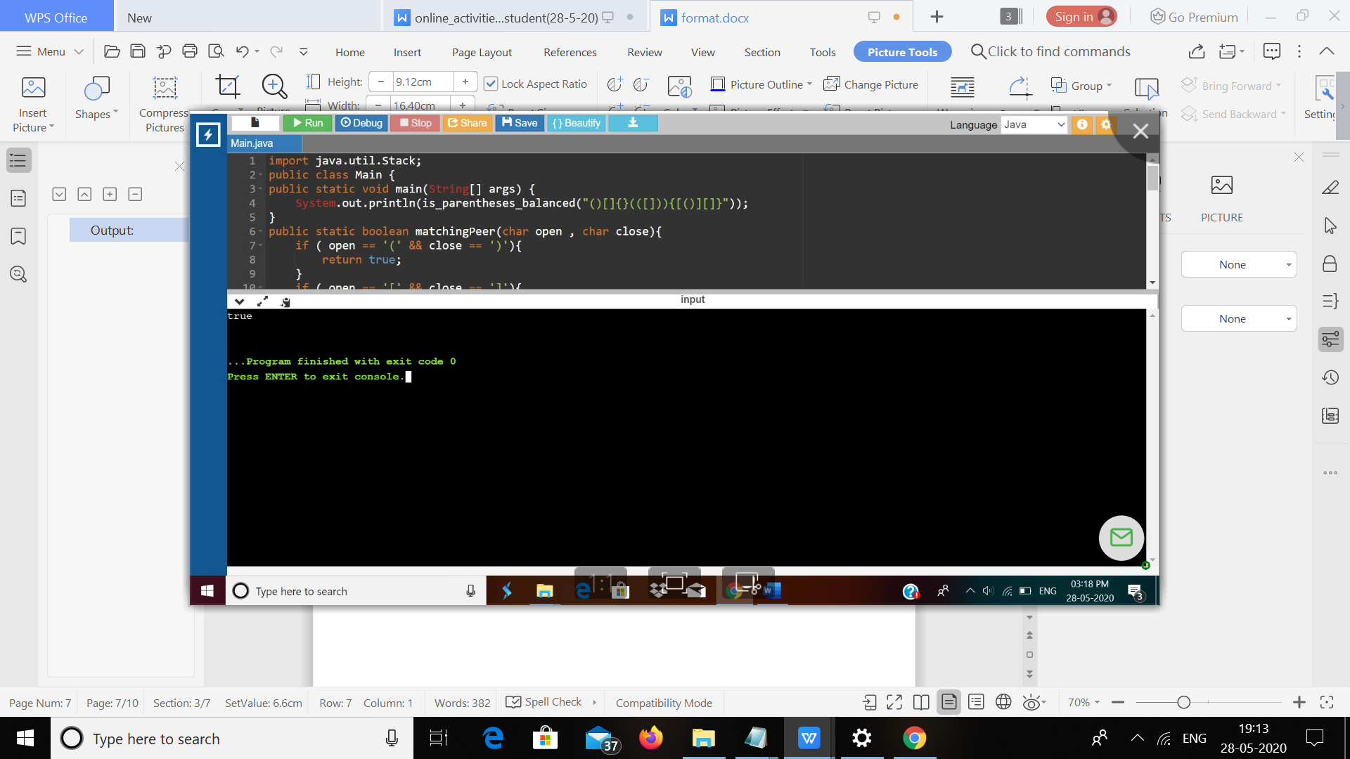

**DAILY ONLINE ACTIVITIES SUMMARY**

|  |  |  |  |  |  |  |  |  |  |
| --- | --- | --- | --- | --- | --- | --- | --- | --- | --- |
| **Date:** | **28/05/2020** | | | | | **Name:** | | **Syed Hudaif Ibrahim** | |
| **Sem & Sec** | **6th /B** | | | | | **USN:** | | **4AL17CS104** | |
| **Online Test Summary** | | | | | | | | | |
| **Subject** | | **OS IA Test - 2** | | | | | | | |
| **Max. Marks** | | **30** | | **Score** | | | **26** | | |
| **Certification Course Summary** | | | | | | | | | |
| **Course** | **Full Stack Web Developer** | | | | | | | | |
| **Certificate Provider** | | | **Udemy** | | **Duration** | | | | **4 weeks** |
| **Coding Challenges** | | | | | | | | | |
| **Problem Statement:**   1. Python Program to print the greatest integer in the list without using sort(). 2. Python Program to find digital root of a number. | | | | | | | | | |
| **Status: Completed** | | | | | | | | | |
| **Uploaded the report in GitHub** | | | | | **Yes** | | | | |
| **If yes Repository name** | | | | | <https://github.com/SyedHudaif/Online-Coding-updates>  <https://github.com/SyedHudaif/Certification-course-updates> | | | | |
| **Uploaded the report in slack** | | | | | **Yes** | | | | |

**Online Test Details**

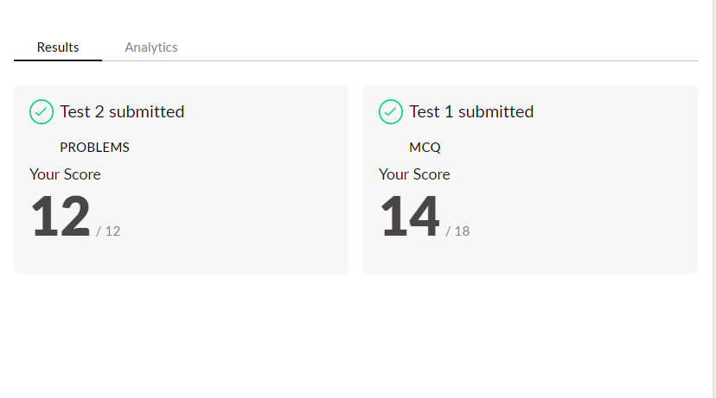

**Online Certification Details**

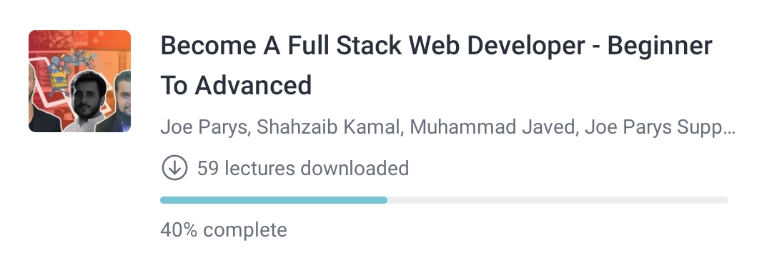

**Coding Challenge Details**

1. Python Program to print the greatest integer in the list without using sort().

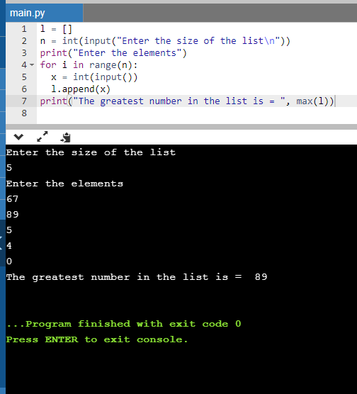

1. Python Program to find digital root of a number.

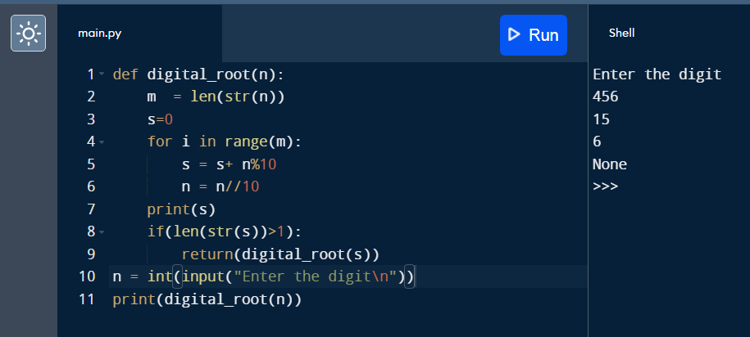

**DAILY ONLINE ACTIVITIES SUMMARY**

|  |  |  |  |  |  |  |  |  |  |  |
| --- | --- | --- | --- | --- | --- | --- | --- | --- | --- | --- |
| **Date:** | **28-05-2020** | | | | | | **Name:** | | **Sneha K Bakale** | |
| **Sem & Sec** | **6th B** | | | | | | **USN:** | | **4al17cs095** | |
| **Online Test Summary** | | | | | | | | | | |
| **Subject** | | **OS** | | | | | | | | |
| **Max. Marks** | | **30** | | **Score** | | | | **27** | | |
| **Certification Course Summary** | | | | | | | | | | |
| **Course** | **Introduction of Cyber Security** | | | | | | | | | |
| **Certificate Provider** | | | **Great learning Academy** | | **Duration** | | | | | **7.0 hours** |
| **Coding Challenges** | | | | | | | | | | |
| **Problem Statement: Programs given** | | | | | | | | | | |
| **Status: Completed** | | | | | | | | | | |
| **Uploaded the report in Github** | | | | | | **Yes** | | | | |
| **If yes Repository name** | | | | | | **https://github.com/Sneha35/OnlineCourse-And-Coding.git** | | | | |
| **Uploaded the report in slack** | | | | | | **Yes** | | | | |

Online Test Details: (Attach the snapshot and briefly write the report for the same)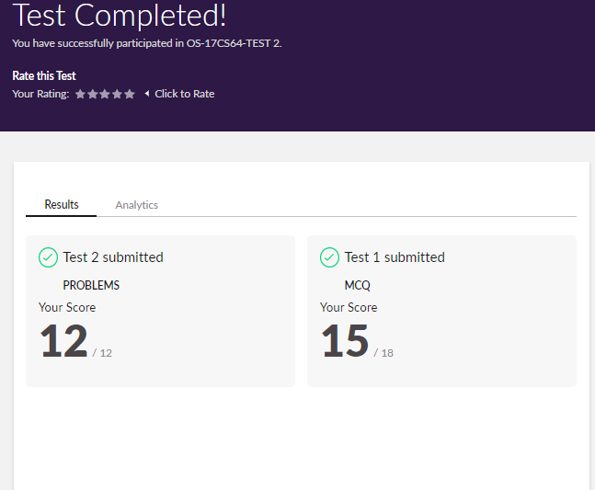

Certification Course Details: (Attach the snapshot and briefly write the report for the same)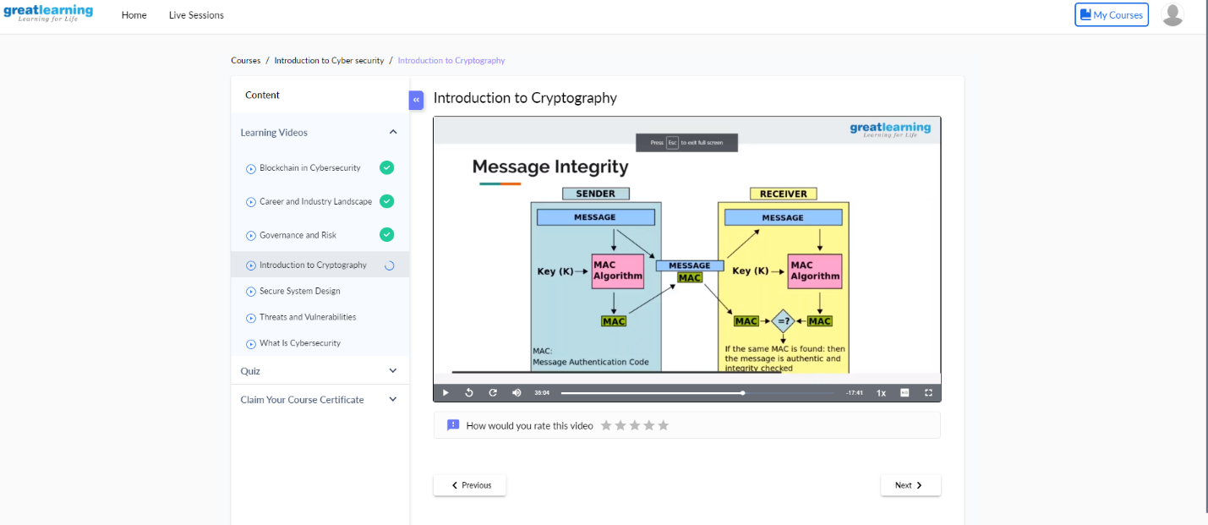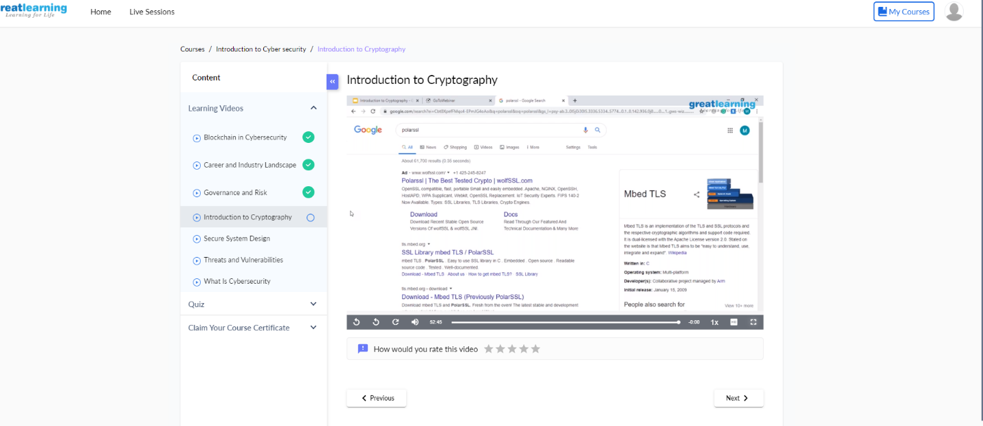

Coding Challenges Details: (Attach the snapshot and briefly write the report for the same) **Output:**



**Output:**





**Output:**



**Output:**



**DAILY ONLINE ACTIVITIES SUMMARY**

|  |  |  |  |  |  |  |  |  |
| --- | --- | --- | --- | --- | --- | --- | --- | --- |
| **Date:** | **28/05/2020** | | | | | **Name:** | **Spoorthy Balaji** | |
| **Sem & Sec** | **6th & B** | | | | | **USN:** | **4al17cs098** | |
| **Online Test Summary** | | | | | | | | |
| **Subject** | | **OS** | | | | | | |
| **Max. Marks** | | **30** | | **Score** | | | **24** | |
| **Certification Course Summary** | | | | | | | | |
| **Course** | **Introduction to Ethical Hacking** | | | | | | | |
| **Certificate Provider** | | | **Great Learning Academy** | | **Duration** | | | **6hours** |
| **Coding Challenges** | | | | | | | | |
| **Problem Statement:** 5Programs | | | | | | | | |
| **Status: Solved** | | | | | | | | |
| **Uploaded the report in Github** | | | | | **yes** | | | |
| **If yes Repository name** | | | | | <https://github.com/spoorthybalaji/Daily_Status> | | | |
| **Uploaded the report in slack** | | | | | **yes** | | | |

IA TEST

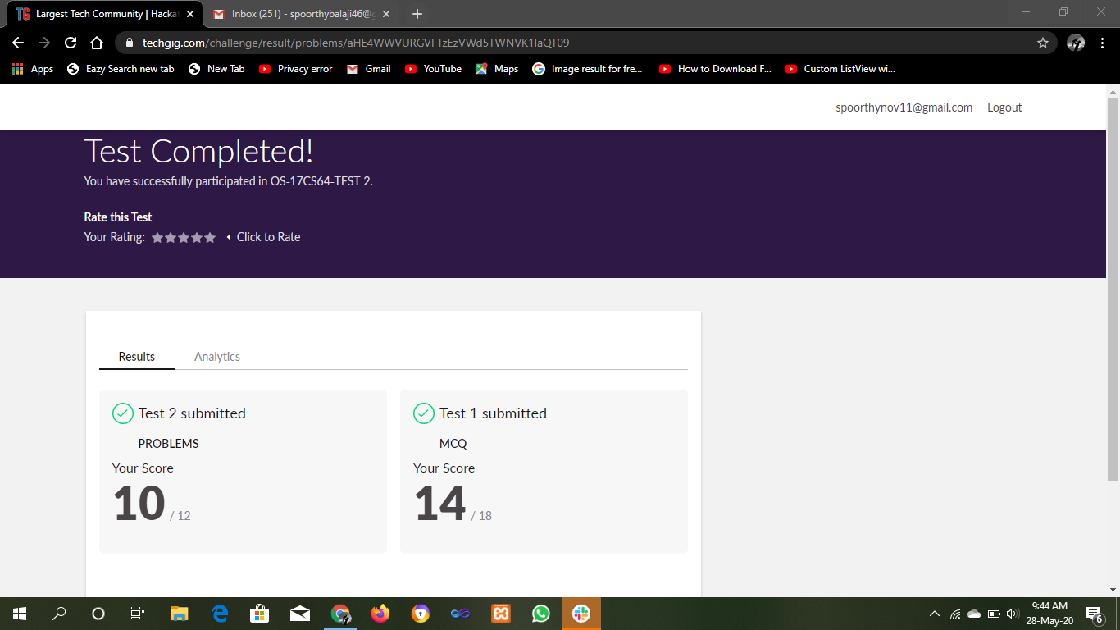

CERTIFICATION COURSE

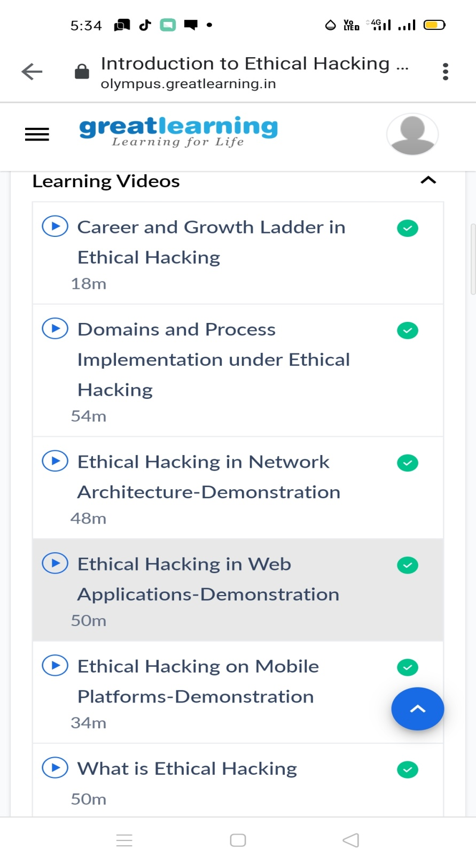

ONLINE CODING

Program output:

